GOVERNOR PATRICK HIGHLIGHTS VISION FOR TECH SECTOR PARTNERSHIP BETWEEN ISRAEL AND MASSACHUSETTS

Trade mission delegation tours Israeli offices of two tech companies based in Massachusetts
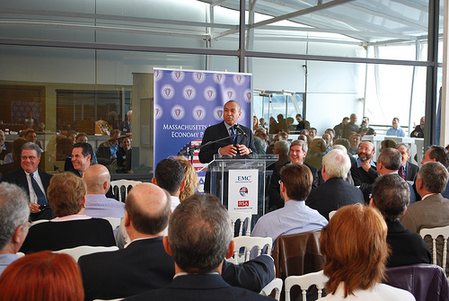

Governor Patrick discusses collaboration between the Massachusetts and Israeli tech sectors at an IT forum hosted by EMC-RSA in Herzliya. (Photo credit: Alex Goldstein/Governor's Office). View additional photos.
HERZILYA - Tuesday, March 8, 2011 - As part of the Massachusetts Innovation Economy Partnership Mission 2011, Governor Deval Patrick today joined a group of business leaders from Israel and Massachusetts to highlight the Commonwealth's vision for a partnership with Israel to accelerate job growth and investment in the tech sector. Governor Patrick is committed to fighting for every job in every corner of the Commonwealth and will pursue this goal through industry forums, company visits and meetings with Israeli business leaders and government officials over the next five days.
"Massachusetts and Israel have a rich history of synergy and collaboration in the tech sector and today we are strengthening those ties," said Governor Patrick. "To compete in the global economy, we will help researchers, entrepreneurs, and executives in Massachusetts and Israel build networks and relationships with others who excel in innovation."
Joined by his tech sector delegation of industry business leaders and state officials, Governor Patrick met with Israeli executives to discuss his vision for partnership and opportunities for Israeli tech sector companies to expand their businesses to Massachusetts at a forum held at the EMC RSA Anti-Fraud Command Center in Herzliya, Israel.
RSA is the cyber security division of Hopkinton-based EMC. Much of RSA's research and development takes place at its Israel headquarters, one of the largest EMC sites in the world. Following the forum, the Massachusetts delegation traveled to the Israel offices of GlassHouse Technologies, a global provider of data center infrastructure consulting services headquartered in Framingham, Massachusetts. The delegation toured the company's facility and debriefed on the morning's forum, engaging directly with each other about possible opportunities for partnership.
Mark Shirman, President, CEO and Chairman of GlassHouse Technologies said, "Global companies tap into and connect with multiple innovative locations to further growth and competitiveness. Both Massachusetts and Israel are tech leaders, so it makes a great deal of sense to strengthen these connections."
"Innovation is a pillar of our economic development strategy," said Greg Bialecki, Secretary of Housing and Economic Development. "Governor Patrick has made it a priority to promote Massachusetts' global leadership in research and innovation to attract and retain the world's top talent, and the most innovative businesses."
"Initiatives such as the Life Sciences Collaborative and the Tech Hub Collaborative informed the design of the RSA forum in Israel," said Patrick Larkin, Director of the Massachusetts Technology Collaborative's John Adams Innovation Institute. "These dialogues are launch pads for projects that yield tangible results for Massachusetts' competitiveness."
Today there are nearly 100 companies with Israeli founders or Israeli-licensed technologies in Massachusetts. In 2009, these companies employed nearly 6,000 people and generated $2.4 billion in direct revenue for the state. Local firms exported over $180 million worth of goods to Israel in 2009 and, at 12.35 percent, the United States is Israel's largest source of imports.
For updates visit www.mass.gov/governor/innovationmission.

