GOVERNOR PATRICK MEETS WITH U.S. AMBASSADOR TO THE UNITED KINGDOM, LOUIS B. SUSMAN
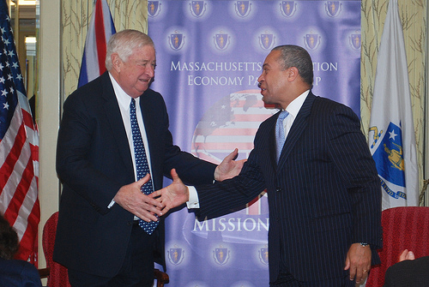

Governor Deval Patrick meets with U.S. Ambassador to the United Kingdom, Louis B. Susman. (Photo credit: Kim Haberlin/Governor's Office).
LONDON - Monday, March 14, 2011 - Massachusetts Governor Deval Patrick today met with U.S. Ambassador to the United Kingdom, Louis B. Susman at the U.S. Embassy in London as part of the Massachusetts Innovation Economy Partnership Mission 2011.
During the meeting with Ambassador Susman, Governor Patrick discussed job-growth opportunities in the Massachusetts and UK innovation industries. Earlier in the day, the Massachusetts delegation of state officials and business leaders received a briefing from Ambassador Susman on the U.S. Government's strong partnership with the UK.
Louis B. Susman was sworn in as U.S. Ambassador on July 29, 2009 by Secretary of State Hillary Clinton. He took up his duties in London on August 17, 2009. Ambassador Susman was previously the Vice Chairman of Citigroup Corporate and Investment Banking. He is also a former member of the Citigroup International Advisory Board. Prior to joining Salomon Brothers, Inc. in June 1989, Mr. Susman practiced law in St. Louis for 27 years and was a senior partner at the St. Louis based law firm of Thompson & Mitchell.
The Massachusetts Innovation Economy Partnership Mission 2011 is focusing on business expansion, job growth and collaboration during industry forums, company visits and meetings with Israeli and UK business leaders and government officials in Tel Aviv, Haifa, Jerusalem, London and Cambridge. The Massachusetts delegation arrived in the United Kingdom on March 12 and will return to Boston on March 17.
For more information, visit http://www.mass.gov/governor/innovationmission.

