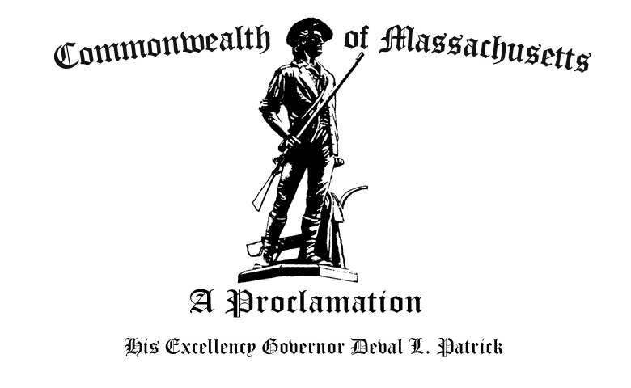

W
hereas Weston, originally part of the Watertown Farms, was settled in 1630 by Sir Richard Saltonstall and Rev. George Phillips; and

W
hereas Weston prosepered along the lucrative Boston Post Road as more doctors resided in town, a sawmill was established, and several bustling taverns were built among the town’s scattered farms; and

W
hereas Weston was formally incorporated as a town in 1713; and

W
hereas By the late 19th century, the local economy began to shift towards industrial endeavors as townspeople pursued the manufacturing of shoes and boots and opened an organ factory while continuing agricultural production; and

W
hereas Weston’s population continued to grow, especially after both World Wars, and the town developed into a model suburban community; and

W
hereas Today Weston proudly displays excellence in public schooling as well as care and attention to over 60 miles of open space for recreation and conservation; and

W
hereas We congratulate the city of Weston and its citizens on the occasion of its tercentennial anniversary and extend greetings as they gather to celebrate this important milestone in the town’s history,

N
ow, Therefore, I, Deval L. Patrick, Governor of the Commonwealth of Massachusetts, do hereby proclaim January 12th, 2013 to be,

Weston Day

And urge all the citizens of the Commonwealth to take cognizance of this event and participate fittingly in its observance.

Given at the Executive Chamber in Boston, January 10th, in the year two thousand and thirteen, and of the Independence of the United States of America, the two hundred and thirty-sixth.

By His Excellency

Deval L. Patrick
Governor of the Commonwealth

William Francis Galvin
Secretary of the Commonwealth

God Save the Commonwealth of Massachusetts

