GOVERNOR PATRICK CONNECTS MASSCHALLENGE START-UPS WITH BRAZILIAN ENTREPRENEURS
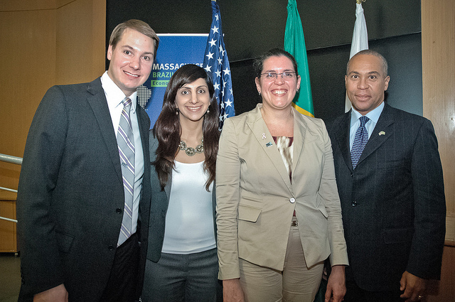

(From Left to Right, John Harthorne, Founder & CEO MassChallenge; Priyanka Bakaya ,PK Clean Chief Executive Officer and Founder; Marcia Fournier, Ph.D. Founder & CEO of BIOARRAY Therapeutics and Governor Deval Patrick- Photo Credit: Governor’s Office)
SÃO PAULO, BRAZIL – Tuesday, December 6, 2011 - Governor Deval Patrick today joined two MassChallenge finalists and Endeavor Brazil to co-host Supporting Entrepreneurship and Innovation in Massachusetts and Brazil. The forum served as an opportunity for start-ups from the two countries to discuss collaboration and job creation in the innovation economy.
“I am proud that through this mission we are able to give two valuable Massachusetts start-ups the opportunity to grow a global partnership,” said Governor Patrick. “Massachusetts and Brazil have the collective brainpower to make us uniquely qualified to lead the world in the innovation industries, and I look forward to our continued partnership.”
Through Governor Patrick’s Innovation Economy Mission, BIOARRAY Therapeutic sand PK Clean, both silver winners of the 2011 MassChallenge start-up competition, were given the opportunity collaborate with Endeavor Brazil - the Brazilian equivalent of MassChallenge.
“The Innovation Economy Mission to Brazil will open many doors for Massachusetts start-ups and MassChallenge teams,” said John Harthorne, Founder & CEO MassChallenge. “Solidifying a partnership between the two economies will strengthen opportunities for investment and job growth.”
BIOARRAY Therapeutics is an early-stage, scientist-founded biotechnology company developing cutting-edge clinical diagnostics to help women with breast cancer and their doctors identify more effective treatment options sooner. BioArray is developing tests based on gene expression profiling that will detect breast cancer at its earliest stages and help determine the best therapy for each individual patient by predicting chemotherapy response across multiple cancer subtypes.
“As the Brazilian molecular diagnostics market continues to grow 14-16% per year, this forum will provide a unique opportunity to develop key collaborations with Brazilian companies and learn from their experiences,” said Dr. Marcia Fournier, Founder & CEO of BIOARRAY Therapeutics.
PK Clean's vision is to turn landfilled plastic waste into a $13 billion annual oil market by selling the crude oil they produce from their patented catalytic depolymerization process. Along with MassChallenge's Silver Award, PK Clean has received numerous other honors including winning the MIT Clean Energy Prize, the Cleantech Open, the Rice Business Plan Competition and is a recipient of Lightspeed Venture’s prestigious Fellowship Award.
“This mission will provide a platform for us to learn, grow, and tap into each other’s markets," says PK Clean Chief Executive Officer and Founder Priyanka Bakaya.
Both countries are emerging markets and economic powerhouses with enormous potential to cultivate partnerships and economic development opportunities in the various innovation industries. Brazil is currently the seventh largest economy in the world, and is expected to rise to fifth in the near future. Like Massachusetts, Brazil’s focus on innovation is driving job growth and catalyzing international investment.
Endeavor Brazil supports high-impact entrepreneurs by providing access to a network of seasoned business leaders, who provide mentorship and strategic guidance. Endeavor is active in 11 countries around the world.
MassChallenge is a $1M global startup competition and accelerator designed to catalyze the launch and success of high-growth, high-impact new businesses. MassChallenge is a 501(c)(3) (nonprofit) and does not take equity from startups or place any restrictions on winners. President Obama honored MassChallenge in January of 2011 as one of the nation's best organizations for supporting high-growth entrepreneurs, and MassChallenge was the youngest inaugural member of the Startup America Partnership. The 111 start-ups supported in the 2010 MassChallenge accelerator raised over $100M in outside funding and created approximately 500 new jobs in under 12 months.
From December 4-9, 2011, the Innovation Economy Mission will make stops in Brasília, São Paulo and Rio de Janeiro, visiting Brazilian companies, universities and government leaders to highlight all that Massachusetts has to offer to Brazil. The mission will focus on creating jobs in the life sciences, IT, clean energy, financial services and education sectors, while solidifying the already strong Massachusetts-Brazil connection. Prior to arriving in Brazil, Governor Patrick and a smaller delegation traveled to Chile December 1-2 at the request of President Sebastian Piñera and signed an agreement to grow jobs and opportunities in the areas of clean energy, biotechnology and education.

