$20.7 MILLION INVESTMENT IN ROXBURY COMMUNITY COLLEGE AS PART OF 2013 CAPITAL PLAN

2013 Capital Plan reflects Administration's commitment to expanding economic opportunity by building world-class public education system
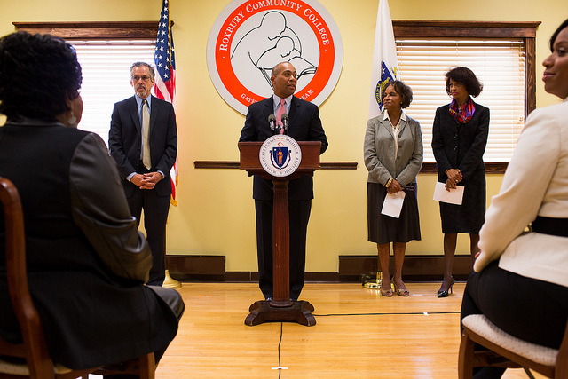
Governor Patrick makes a capital funding announcement at Roxbury Community College. (Photo Credit: Stephen Speranza / Governor's Office) View additional photos.
BOSTON – Tuesday, October 2, 2012 – Governor Deval Patrick today announced $20.7 million in capital funds for Roxbury Community College, furthering the Patrick-Murray Administration’s commitment to building an affordable, world-class system of public higher education in Massachusetts. The college will use the funds, which it will receive over five years through the Administration’s 2013 Capital Plan, to upgrade and renovate the Academic and Media Arts building. The bond money will also support study and planning related to new infrastructure for life science and allied health programming.
"Roxbury Community College is full of talent and promise and potential,” said Governor Patrick. “These funds will help the students and faculty seize the opportunities before them.”
Last week, the Governor awarded Roxbury Community College a $35,517 grant to focus on the college’s nursing assistant program and enhance the English collaborative with UMass Boston. Part of a $4 million round of awards, that funding will support increased skill training and workforce alignment, improved student learning outcomes and efficiency measures at community colleges across the Commonwealth. These grants, along with the capital investments in community college campuses and programs, deliver on the goals of the Governor’s community college initiative to put more people in Massachusetts back to work and to strengthen the connections between community colleges, employers and the workforce.
“The Patrick-Murray Administration has made investing in public higher education a priority,” said Secretary of Administration and Finance Jay Gonzalez. “By financing these capital projects the University of Massachusetts system will have the resources necessary to ensure our students have the knowledge to thrive and succeed.”
“These investments will not only allow our campuses to better equip our students with the skills they need to succeed in the classroom and in the workforce, but will also benefit entire communities in their respective regions,” said Education Secretary Paul Reville.
In 2008, Governor Patrick proposed and the Legislature approved a $2.2 billion higher education bond bill. In FY13, the Commonwealth’s capital investment in higher education will be more than three times the total amount invested in FY07, when Governor Patrick took office. The full plan will be released in its entirety next week.

