GOVERNOR PATRICK CELEBRATES PROGRESS ON GREENWAY'S ARMENIAN HERITAGE PARK

A Tribute to Armenian Heritage, Massachusetts Immigrant History to be Located on Parcel 13
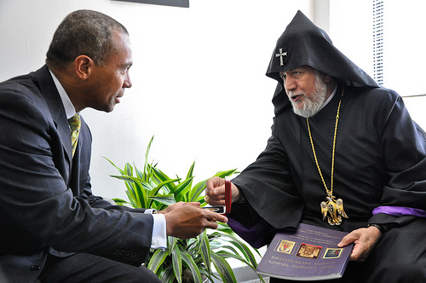
(Photo credit: Matt Bennett/Governor's Office). View additional photos.
BOSTON - Thursday, September 9, 2010 - Governor Deval Patrick today joined His Holiness Karekin II, Catholicos of All Armenians, Armenian-American citizens and City and Commonwealth officials in celebrating the planned Armenian Heritage Park for the Rose Fitzgerald Kennedy Greenway.
The Armenian Heritage Park will be located on Parcel 13 of the Greenway between Faneuil Hall and Christopher Columbus Park. The $2.2 million park construction project advertised for bid this month will be overseen by the Massachusetts Department of Transportation and funded entirely by the Armenian Heritage Foundation. The Foundation will have permanent responsibility for Heritage Park maintenance.
"I am honored to join His Holiness Karekin II to celebrate what will be a beautiful addition to the Greenway as well as a testament to the heritage of Armenian-Americans and Massachusetts' larger immigrant history," said Governor Patrick.
"This park celebrates the distinctive history of the City of Boston and the generations of immigrants who have made Boston the wonderfully diverse community it is today," said Mayor Thomas M. Menino. "It will add to the beauty and vitality of the Rose Kennedy Greenway for future generations of Boston residents and visitors to enjoy."
The Park will consist of two prominent features: a metal, twelve-sided sculpture mounted in a reflecting pool on raised granite and a circular lawn panel 75 feet in diameter with a fountain at its center. The sculpture is in two pieces and will be reconfigured annually. The circular lawn panel is bordered by a granite walkway, seat-walls, and benches. The park will also include shade and ornamental trees, shrubs, groundcovers, perennials, and bulbs intended to provide seasonal interest, shade, and a buffer for park users from the adjacent street traffic.
"We appreciate the collaboration of the Armenian Heritage Foundation and the North End community in their efforts to create additional beauty in the heart of the City," said Senator Anthony Petruccelli. "The Park will help provide a perpetual gathering place for visitors, residents and lecturers."
"With today's groundbreaking the Commonwealth moves one step closer to fulfilling the promise of the Rose Kennedy Greenway as an active and vibrant part of the City," said Representative Aaron Michlewitz. "I welcome the Armenian community to the North End and look forward to a great relationship with them in the future."
"This day has been 10 years in the making," said Representative Peter Koutoujian. "It is a proud day for the Armenian-American community and one we are eager to share with the people of the Commonwealth and the world."
"We can all be very grateful to the Armenian-American community of Massachusetts for this tremendously meaningful addition to the Greenway. It will be an inclusive space for residents and visitors to commemorate the Armenian Genocide and all other genocides, and to celebrate the immigrant experience and its contribution to our Commonwealth," said Representative Jonathan Hecht.
Park construction is expected to be completed within 12 months.

