LIEUTENANT GOVERNOR MURRAY WELCOMES HOME MASSACHUSETTS TROOPS
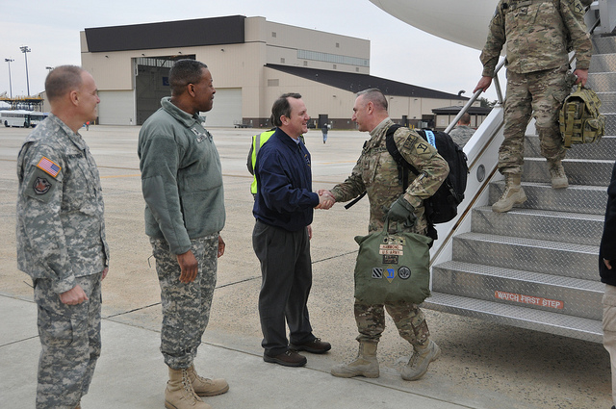

Lieutenant Governor Timothy Murray and Major General Joseph C. Carther welcome home members of the Massachusetts National Guard. (Official U.S. Air Force Photo/2nd Lt. David J. Murphy).
BOSTON – Friday, February 3, 2012 – Lieutenant Governor Timothy Murray yesterday joined Major General Joseph C. Carter of the Massachusetts National Guard to welcome home Massachusetts troops from the 26th Maneuver Enhancement Brigade at the Joint Base McGuire-Dix-Lakehurst in New Jersey.
Prior to the welcome home ceremony, Lieutenant Governor Murray was led on a tour of Joint Base McGuire-Dix-Lakehurst, which included a comprehensive overview of reintegration services on the base such as medical treatment and financial assistance provided to troops in preparation for their return to their home communities.
“I appreciate the invitation to join Major General Carter in welcoming Massachusetts troops back to the United States,” said Lieutenant Governor Murray, Chair of the Governor’s Advisory Council on Veterans’ Services. “These men and women have bravely protected our nation, some experiencing multiple tours overseas. Now, upon their return home, we have a moral obligation to ensure our veterans and their families receive the services they have rightfully earned as they integrate back into their communities and the Commonwealth.”
“It was a heartwarming honor to welcome home our citizen-soldiers from the 26th Maneuver Enhancement (Yankee) Brigade upon completion of their one year mobilization supporting Operation Enduring Freedom,” said Major General Carter, The Adjutant General, Massachusetts National Guard. “The Yankee Brigade has perpetuated the outstanding legacy of the 26th Yankee Division, contributing to the unit's record of success that includes distinguished overseas service in both World Wars.”
Since 2007, Lieutenant Governor Murray has led the Governor’s Advisory Council on Veterans’ Services which coordinates interagency collaboration with the Massachusetts Department of Veterans’ Service (DVS) as well as local, state and federal agencies and organizations.
With more than 385,000 veterans currently living in Massachusetts, including 37,000 men and women who have served in Iraq and Afghanistan since 9/11, the Patrick-Murray Administration has worked to ensure newly returning veterans, as well as Massachusetts’ aging veteran population, continue to receive quality health, housing and employment services to honor their service. Last week, Lieutenant Governor Murray announced that the Patrick-Murray Administration’s Fiscal Year 2013 budget proposal includes $11.25 million in increased funding to enhance vital services for Massachusetts veterans and their families.
Massachusetts leads the nation in providing services for veterans and military families. The Governor’s Advisory Council on Veterans’ Services and DVS advocates on behalf of the Commonwealth's nearly 500,000 veterans, family members, and survivors. DVS works to secure federal compensation and other benefits for which veterans may be eligible. DVS also administers needs-based benefits program through Veterans' Service officers across Massachusetts and provides state funding to organizations offering homeless shelter, transitional housing, and outreach services to veterans. To learn more about veterans’ services, visit www.mass.gov/veterans.

