GOVERNOR PATRICK ANNOUNCES $4 MILLION FOR COMMUNITY COLLEGES

Grants will increase skill training, workforce alignment; continue efforts to develop unified and strengthened community college system
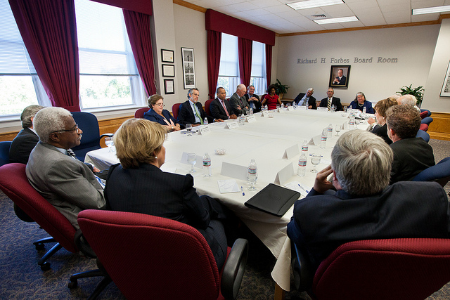
Governor Patrick joins legislators to announce $4 million in grants to support community colleges across the Commonwealth. (Photo Credit: Eric Haynes / Governor's Office) View additional photos.
WELLESLEY – Tuesday, September 25, 2012 – Governor Deval Patrick today announced $4 million in grants to support increased skill training and workforce alignment, improved student learning outcomes and efficiency measures at community colleges across the Commonwealth. These grants deliver on the goals of the Governor’s community college initiative to put more people in Massachusetts back to work and to strengthen the connections between community colleges, employers and the workforce.
"A stronger community college system is good for students, employers and the whole Commonwealth," said Governor Patrick. "These additional resources will further accelerate this transformation, and help get people to work.”
“By partnering with our community colleges and strengthening their ties to businesses and career training, we will help close the skills gap facing many industries,” said Lieutenant Governor Timothy Murray. “Ensuring more students and those seeking work are trained in science, technology, engineering and math (STEM) is a major component of our efforts to increase skill training and support job creation and professional growth.”
The community college grants awarded today through the Performance Incentive Fund (PIF) deliver on Governor Patrick’s pledge to invest further in our community college system, and will give campuses the additional capacity they need to promote higher completion rates of degrees and certificates, be more responsive to the needs of local economies as well as of the state’s fastest growing sectors and adopt a system-wide standard core of course offerings.
The FY13 budget, supported by the Legislature and signed by the Governor in July, set aside $5 million for community colleges to be used for 1) the development of efficiency measures that may include consolidation of information technology platforms and services; 2) creating innovative methods for delivering quality higher education that increase capacity, reduce costs and promote student completion; 3) engaging in statewide and regional collaborations with other public higher education institutions that reduce costs, increase efficiency and promote quality in the areas of academic programming and campus management; and 4) improving student learning outcomes assessments set forth by the Board of Higher Education under the Vision Project. These grants also support the Administration’s goals of increasing workforce alignment between community colleges and local/statewide employers and providing students with additional skills training in high-demand fields.
“These grants will support our efforts to connect more of our students to meaningful work and will help provide more of those students with the educational and skill-building opportunities they will need to succeed in our knowledge-based economy,” said Education Secretary Paul Reville.
“As our economic recovery continues we are finding employers in some areas, such as advanced manufacturing, need assistance connecting with available, skilled workers,” said Housing and Economic Development Secretary Greg Bialecki. “The grants announced by Governor Patrick and other initiatives designed to connect employers with workers are part of our long-term economic planning goal of building and maintaining a workforce that is talented, well-trained and meeting the needs of businesses.”
“We look forward to seeing these grants applied to advancing the skills of our workforce,” said Labor and Workforce Development Secretary Joanne F. Goldstein. “Current and diverse career training curriculum is essential to re-employment and to help incumbent workers move forward. Our state’s career centers are already engaged with the community college system and businesses, and we will continue to foster collaborations to help our talented labor pool succeed in today’s developing marketplace.”
“I am thrilled to join with Governor Patrick and Secretary Reville in announcing these awards,” said Higher Education Commissioner Richard M. Freeland. “They reflect an impressive commitment across our community colleges to achieve a central goal of the Vision Project, which is to ensure that maximum numbers of our students achieve their educational goals.”
"We are delighted by the Commonwealth's investment in its community colleges and its recognition of their importance to the health of our state and local economies," said Holyoke Community College President Bill Messner. "These funds will strengthen our ability to serve as a gateway to careers and continued education for our communities."
Of the $5 million allocation, $2.9 million is being awarded to fund new initiatives, $500,000 is being awarded as second year grants to projects funded last year under the PIF and $400,000 will be used to implement a system-wide credit transferability infrastructure. Grants to award the remaining $1 million balance will be announced later this year to incentivize credit transferability and efficiency measures among campuses.
"This funding demonstrates the Administration's commitment to improving performance and accountability, which sets the tone for greater support from the business and philanthropic sectors," said Paul S. Grogan, President of the Boston Foundation, which convened the Coalition FOR Community Colleges in support of needed reforms. “Business and civic leaders can and will effectively advocate for increased investment in higher education system when the system functions with greater accountability and alignment with workforce needs.”
Today’s awardees are as follows:
- Berkshire Community College - $88,000 to accelerate college readiness and developmental math pathways; and enhance student advising and civic engagement programming.
- Bristol Community College - $299,994 to address college readiness, improve developmental education and increase student retention.
- Bunker Hill Community College - $203,000 to focus on college going rates, career pathways and civic engagement.
- Cape Cod Community College - $137,211 to enhance college readiness in the Cape Cod area and to retain increasing numbers of students at the college.
- Greenfield Community College - $179,310 to expand a hybrid learning model of online learning combined with onsite learning.
- Holyoke Community College - $167,883 to support the college’s Gateway to College Prep program, help increase graduation and student success rates, support ongoing work to develop student learning assessments and increase civic engagement among its students.
- MassBay Community College - $300,000 to enhance the first year experience for MassBay students, positively impacting student retention.
- Massasoit Community College - $215,000 for a new civic engagement initiative, enhanced student success activities and more focused work force training.
- Middlesex Community College - $251,000 to enhance tutoring for at risk students and to increase work force alignment activity.
- Mt. Wachusett Community College - $272,000 to increase college readiness and ultimate attendance rates, improvement of student success at the College and a new commitment to civic engagement activity.
- North Shore Community College - $174,356 to develop a virtual career center that complements the career mapping project funded with performance improvement funds last year.
- Northern Essex Community College - $146,744 to support advanced activity related to student learning and student learning assessment.
- Quinsigamond Community College - $136,481 for an initiative called “shorten the distance” that supports both student’s readiness for college and student success at the College once admitted.
- Roxbury Community College - $35,517 to focus on the college’s nursing assistant program and enhance the English collaborative with UMass Boston.
- Springfield Technical Community College - $291,058 for expanding important student learning assessment activity.

