GOVERNOR PATRICK PAYS RESPECTS AT CAMBRIDGE AMERICAN CEMETERY AND MEMORIAL SITE IN UK
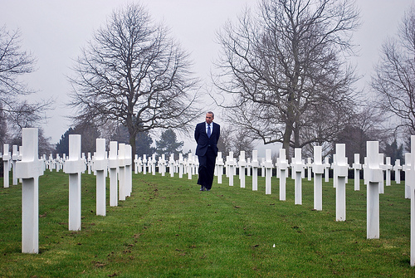

Massachusetts Governor Deval Patrick pays respects at Cambridge American Cemetery in Madingley, UK.(Photo credit: Jack Murray). View additional photos.
MADINGLEY, UK - Tuesday, March 15, 2011 -Massachusetts Governor Deval Patrick today visited the Cambridge American Cemetery and Memorial in Madingley, UK to pay respects to fallen U.S. military members from World War II.
During his visit, Governor Patrick laid a wreath in honor of Massachusetts-born fallen service members, and presented the cemetery with a Massachusetts flag previously flown over the State House in honor of the state's service members who are buried, or listed as missing.
Governor Patrick also placed flowers on the grave of Technical Sergeant Chester W Yurick, of Needham, MA. Yurick served as radio operator on a B-24 Liberator from the 44th Bomb Group based at Shipdham in Norfolk, England. He and his crew died following a crash landing after their aircraft was damaged by German defenses.
Today the cemetery's flags were flown at half-staff in honor of recently-deceased Naval officer John W. Finn, who received the Medal of Honor for heroism at Pearl Harbor.
The Cambridge American Cemetery and Memorial site was donated by the University of Cambridge and occupies 30.5 acres in total. The cemetery contains the remains of 3,812 American military dead, including 360 from Massachusetts, with another 5,127 names recorded on the Tablets of the Missing. Many of the soldiers buried at the cemetery died in the Battle of the Atlantic in World War II, or in the strategic air bombardment of northwest Europe.
The visit was made during the Massachusetts Innovation Economy Partnership Mission 2011, which is focusing on business expansion, job growth and collaboration between Massachusetts, the UK and Israel. The Massachusetts delegation arrived in the UK on March 12 and will depart on March 17 to return to Boston.
For updates, please visit www.mass.gov/governor/innovationmission.

