REPORT CONFIRMS THAT GOVERNOR PATRICK'S LIFE SCIENCES INITIATIVE IS CREATING JOBS AND ECONOMIC OPPORTUNITY

Massachusetts leads the nation in creating jobs in the life sciences sectors
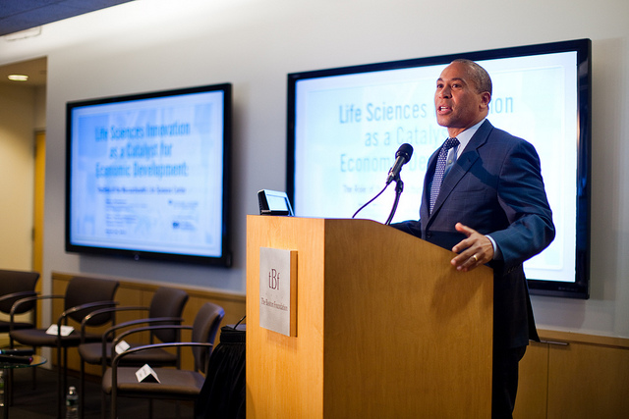
Governor Patrick joins the Boston Foundation for an announcement relative to the Massachusetts Life Sciences sector. (Photo credit: Eric Haynes / Governor's Office)
View more photos
BOSTON – Tuesday, March 26, 2013 – The Boston Foundation today released a report showing that the Patrick-Murray Administration’s investments in the life sciences sector are making a measurable impact on job creation and spurring economic growth across the Commonwealth. The report also encourages continued funding of the Life Sciences Initiative, the Administration’s 10-year $1 billion investment package in the Life Sciences industries that has helped make Massachusetts a national leader in this growing sector.
“The Life Sciences Initiative is meeting its growth objectives and then some,” said Governor Deval Patrick in an event announcing the report at the Boston Foundation earlier today. “Because we chose to shape the future we wanted, rather than just wait to see what happens, Massachusetts is now the world's leading life sciences supercluster, and we have the jobs and economic opportunity that come with that.”
In 2007, Governor Patrick proposed a 10-year, $1 billion Massachusetts Life Sciences Initiative. The initiative was passed by the Legislature in 2008, and the Massachusetts Life Sciences Center (MLSC) was charged with implementing it. The goal of this initiative has been to make the Commonwealth home to the most vibrant life sciences supercluster in the world, attracting investment dollars, creating well-paying jobs, expanding a technically skilled workforce and supporting an energetic landscape for innovation and entrepreneurship.
The report, Life Sciences Innovation as a Catalyst for Economic Development: The Role of the Massachusetts Life Sciences Center, was unveiled earlier today at an Understanding Boston forum at the Boston Foundation. The research found that the MLSC has had a measurable impact on job creation through its over $300 million in investments as of June, 2012. Over the last 10 years the state’s life sciences cluster has created jobs in Massachusetts at a faster pace than any other industry sector in the Commonwealth, and since 2008, Massachusetts has overtaken all competitor states in the rate of life sciences job creation. The report also commends the MLSC for its administrative efficiency and sound judgment in its investments and applauds the Governor and the Legislature for its foresight in creating the Center.
The MLSC is driving job creation in Massachusetts through several different programs, including loans to early-stage companies, grants to support industry-academic research collaborations, cutting edge infrastructure, growth incentives, workforce training and internships that help smaller companies access Massachusetts workers. The research found that the MLSC’s investments in start-up companies is an especially strong draw to Massachusetts for larger companies, which rely on smaller companies to help them access and develop new technologies at a faster rate. The MLSC’s role in helping these start-up firms gain traction in Massachusetts has been instrumental in encouraging the larger bioscience companies to locate and create jobs in the Commonwealth.
Building on these targeted investments, Governor Patrick unveiled a budget proposal in January that includes new investments in education and transportation, investments that have proven to create new jobs and economic opportunities. The Governor’s plan includes a $1 billion annual investment in the Commonwealth’s transportation system to maintain the transportation assets we have today and launch a number of high-impact transportation projects across Massachusetts that, if built, will create thousands of jobs and spur economic development across the Commonwealth. The plan also includes a $550 million investment in education, reaching $1 billion over four years, to expand access to high quality educational opportunities and make higher education more affordable for all students in Massachusetts.
The report was conducted through the Kitty and Michael Dukakis Center for Urban and Regional Policy at Northeastern University and authored by Barry Bluestone and Alan Clayton-Matthews. Click here to view the full report.

