GOVERNOR PATRICK ANNOUNCES THIRD PHASE OF PENSION REFORM

Continues efforts to modernize the pension system; Find efficiencies and cost-savings in state government
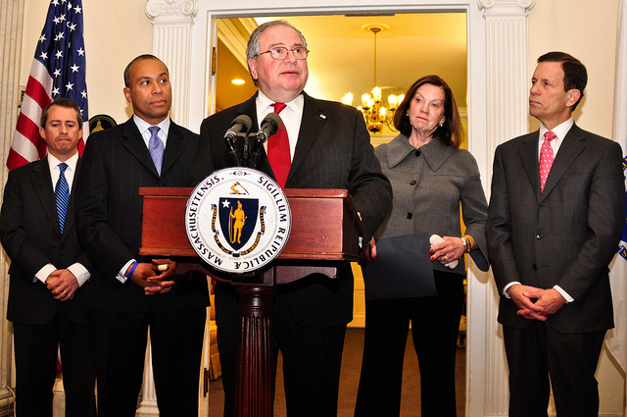
Governor Patrick and other top officials discuss pension reform at the State House. (Photo credit: Matt Bennett/Governor's Office).
BOSTON - Tuesday, January 18, 2011 - Continuing the Patrick-Murray Administration's efforts to identify efficiencies and cost-savings in state government, Governor Deval Patrick today announced his proposal for the next phase in pension reform. This proposal will build on pension reform legislation, signed during the Administration's first term, that closed loopholes and eliminated the most egregious abuses in the public retirement system.
Pension Reform III will further overhaul the benefits plan to ensure its long-term sustainability and credibility. Coupled with Pension I and II, this reform package is expected to save taxpayers more than $5 billion in pension costs over 30 years, and $2 billion in retiree health benefit costs for new employees over the next 30 years.
"We have committed to fix what's broken in state government. That's why, in partnership with the legislature, we enacted long-awaited reforms in ethics, transportation, education and state pensions," said Governor Patrick. "Today, I'm proud to stand with our partners in the Legislature and Treasurer's office to announce the filing of the next set of reforms in the state pension system."
"The changes Governor Patrick is proposing today will ensure the public employee pension system is fair, credible and fiscally sustainable," said Administration and Finance Secretary Jay Gonzalez. "Doing nothing is not an option. If we don't take action now, there will not be a pension system for retirees in the future."
"We have made a number of significant reforms to the pension system over the last two years, closing loopholes and eliminating special benefits, but we can do more to maintain the system and establish a more equitable public benefit for all employees," said Senate President Therese Murray. "The reforms announced today, including a number that were endorsed by the Senate last year, are a step in the right direction and deserve attention from the Legislature. Reasonable adjustments to modernize the system are appropriate, and I will review the Governor's proposal closely with the Senate."
"Last session we changed the way government does business more profoundly than at any time in recent history by passing sweeping ethics, pension, transportation and education reform," said House Speaker Robert A. DeLeo. "Having done away with entrenched pension loopholes, I am committed to continuing reform in this area."
"It is essential that the proposed extension of the deadline for fully funding our pension system be coupled with strong and comprehensive reforms," said Treasurer-elect Steve Grossman. "Massachusetts has earned a high bond rating - which saves taxpayers millions annually - by living within its means and dealing aggressively with financial challenges before they become insurmountable. The plan that the Governor has announced today strikes the necessary balance among the interests of the taxpayers, the investment community and public employees."
Pension Reform III core components:
Increase the retirement age for virtually all state workers, reflecting the fact that people are living and working longer.
This change will more closely align the state system with the retirement ages already set by the federal government for Social Security benefits.
- Group 1 (elected officials and most general employees): Increase the retirement age to 60-67 from the current 55-65;
- Group 2 (employees with titles reflecting hazardous duties): Increase the retirement age to 55-62 from the current 55-60;
- Group 3 (state police): The maximum benefit is currently reached with 25 years of service. Our proposal would increase this to 30 years by lowering the benefit factor after 20 years of service from 3.0 to 2.5 per year of service;
- Group 4 (firefighters, police officers, some corrections officers): Increase the retirement age to 50-57 from the current 45-55
Eliminate early retirement subsidies
The current system provides an incentive for those who have reached minimum retirement age to retire before reaching maximum retirement age, as the increase in benefits resulting from additional years of service is less than the benefit of additional years of pension. The Administration's proposal would eliminate this incentive.
Reduce Group 1 Contribution Rate
Reduce the 9 percent contribution rate of new Group 1 employees and the 11 percent contribution rate of new teachers by 0.5 percent. This reduction protects new Group I employees who, as a result of changes to the system, will be contributing for a longer period of time.
Increase "high 3" to "high 5"
Increase the period for averaging earnings, for purposes of calculating a member's retirement allowance, from 3 to 5 years. A slightly longer averaging period more accurately reflects an employee's career earnings.
Eliminate Section 10 early retirements for all employees
Currently, employees with 20 years of service who are terminated at no fault of their own are entitled to an early retirement benefit equal to one third of their high 3 earning years, plus an annuity from contributions. In most cases, that lifetime termination benefit is significantly larger than what the employee would have received if not terminated, and declines with further increases in age and service. Under the Administration's proposal, employees would not be eligible for early retirement until they reach minimum retirement age, and all employees within each Group would receive these benefits based on the same formula.
Pro-rate benefits based on employment history
The Administration's proposal would pro-rate the retirement allowance for employees who have served in more than one Group, taking into account the number of years of service in each Group. Pro-rating prevents windfalls for people who have only a short period of service in a Group with higher benefit levels at the end of their career.
Introduce an anti-spiking rule
The Patrick-Murray proposal would introduce an "anti-spiking rule" which would limit the annual increase in pensionable earnings to no more than 7 percent of the average pensionable earnings over the last two years plus inflation. This provision would not apply to bona fide promotions or job changes.
Eliminate "Double Dipping"
Pension Reform III would eliminate the right to receive a pension while receiving compensation for service as an elected official.
Other provisions include:
- Increase scrutiny of legislation benefiting individual employees by requiring such legislation to be accompanied by an actuarial cost estimate, confirmation of the cost analysis from the Public Employees Retirement Commission and a recommendation from the Retirement Board.
- Require elected officials to repay the full value of the pension they have received in order to rejoin the system, consistent with what all other state employees are required to do.
- Require members who rejoin the system or new members eligible to receive creditable service based on work elsewhere to purchase creditable service within one year or pay the full actuarial interest rate.
- Allow retirement boards to require retirees convicted of a criminal offense related to their employment to repay benefits received since the date of the offense, not just the date of conviction.
- Establish a special commission to study the Massachusetts public employees' pension classification system. The commission will review and make recommendations for reform regarding the Massachusetts public employees' group classification system, beginning with consideration of the work by the Blue Ribbon Panel on the Massachusetts Public Employees Pension Classification System.
- Allow retirees who married a person of the same sex within the first year after it became legal to change their retirement option in order to provide a benefit to their spouse.
The Commonwealth's public employee retirement system is a defined benefit plan that provides retirement and disability benefit levels similar to those of other states with defined benefit plans and no Social Security coverage for public employees.

