GOVERNOR PATRICK MEETS WITH LEADERS IN SÃO PAULO’S INNOVATION ECONOMY
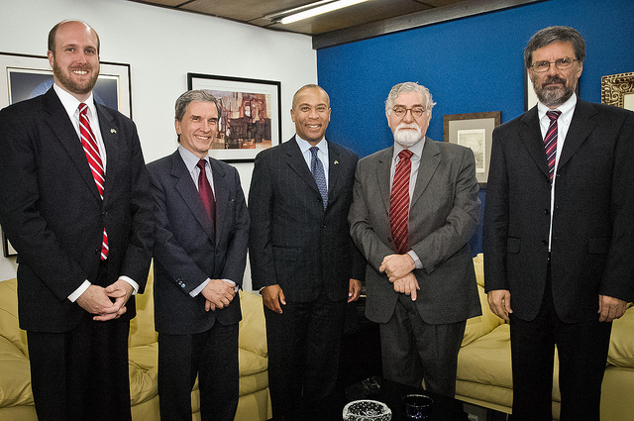

From left to right Acting Consul General William Popp, Consul General of Brazil in Boston Fernando de Melo Barreto, Governor Deval Patrick, President of FAPESP Celso Lafer and Scientific Director Carlos Henrique de Brito. (Photo: Governor's Office)
Click here to view photos from Brazil and Chile
São Paulo, Brazil - December 6, 2011- Governor Deval Patrick today joined members of the São Paulo Research Foundation (FAPESP) to discuss job creation in the science and technology sectors and initiatives to cultivate industry partnerships and research collaborations between Massachusetts and Brazil in the innovation economy.
“Massachusetts is a global leader in innovation and home to world-class academic and research institutions,” said Governor Patrick. “Today we are exploring ways to expand job growth opportunities and scientific discovery in our common innovation industries.”
Governor Patrick met with Celso Lafer, President of FAPESP, who discussed Brazil’s efforts to create jobs in the innovation economy. Like Massachusetts, Brazil’s focus on innovation is driving job growth and catalyzing international investment. As an emerging global player and economic powerhouse, Brazil could quickly become one of the most important international economic partners for Massachusetts.
“Massachusetts is a global leader in the life sciences, but to maintain and strengthen that status we need to engage the rest of the world,” said Susan Windham Bannister, Ph.D., President and CEO of the Massachusetts Life Sciences Center. “Brazil is an emerging leader in the life sciences, and through this meeting and the others we are holding here we are looking to develop collaborations that will lead to concrete scientific and economic benefits for both regions.”
“The University of Massachusetts has global research reach and an ever-expending portfolio, with research funding now exceeding $500 million a year,” said UMass President Robert L. Caret. “We are eager to expand our research collaborations with colleagues in Brazil and commend Governor Patrick for opening doors and nurturing relationships. The research areas the Governor is targeting play well to our strengths at the University of Massachusetts, and we look forward to forming partnerships that will pay academic and economic dividends.”
FAPESP is an independent public foundation with the mission to foster research and the scientific and technological development in the state of São Paulo. This is achieved through the support of research projects carried out in higher education and research institutions, in all fields of knowledge. In 2010, the population of the state of São Paulo stood at over 41 million.
From December 4-9, 2011, the Innovation Economy Mission will make stops in Brasília, São Paulo and Rio de Janeiro, visiting Brazilian companies, universities and government leaders to highlight all that Massachusetts has to offer to Brazil. The mission will focus on creating jobs in the life sciences, IT, clean energy, financial services and education sectors, while solidifying the already strong Massachusetts-Brazil connection. Prior to arriving in Brazil, Governor Patrick and a smaller delegation traveled to Chile December 1-2 at the request of President Sebastian Piñera and signed an agreement to grow jobs and opportunities in the areas of clean energy, biotechnology and education.

