GOVERNOR PATRICK CELEBRATES PFIZER EXPANSION IN CAMBRIDGE

Company to bring 400 new research jobs to Cambridge
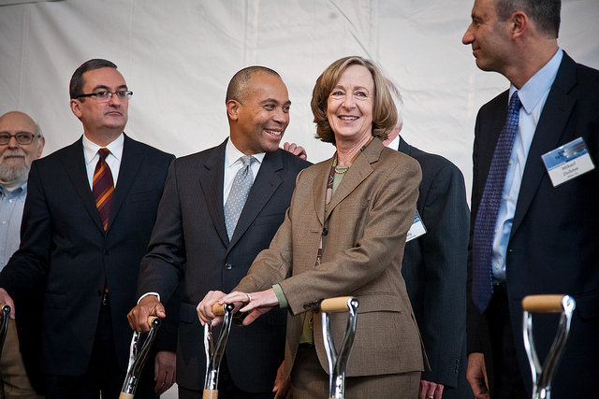

Governor Deval Patrick today joined Pfizer and the Massachusetts Institute of Technology (MIT) to break ground on Pfizer’s new facility in Cambridge's Kendall Square. The facility will allow the company to expand its footprint in the growing biopharmaceutical cluster in Cambridge and will create 400 new jobs.(Photo: Eric Haynes / Governor's Office)
CAMBRIDGE – Monday, November 21, 2011 – Governor Deval Patrick today joined Pfizer and the Massachusetts Institute of Technology (MIT) to break ground on Pfizer’s new facility in Cambridge's Kendall Square. The facility will allow the company to expand its footprint in the growing biopharmaceutical cluster in Cambridge and will create 400 new jobs.
“It is welcome news that Pfizer is increasing its presence and bringing new jobs to Massachusetts,” said Governor Patrick. “Companies like Pfizer know that Massachusetts is unmatched when it comes to providing a high-quality workforce, a high quality of life, and nation-leading investments in health care, education and innovation.”
Pfizer announced in February 2011 that the company would be making a strategic shift in research and development. Part of this strategic plan included turning the company’s focus on a smaller number of research areas where the potential impact is greatest. This included the company’s CVMED and Neuroscience research units. To help accommodate these changes, Pfizer announced it would increase its presence in Cambridge by moving these two important research units there, making the company the second largest biopharmaceutical company in Massachusetts in terms of number of employees. In September, Pfizer announced it had entered into a 10-year lease agreement with MIT for more than 180,000 square feet.
“We deliberately chose to move to Cambridge as a key part of our research and development strategy, in order to foster productive collaborations between our drug discovery experts and the outstanding scientists of Cambridge’s world-class institutions,” said Pfizer Worldwide R&D President Mikael Dolsten.
"Global biopharma leaders like Pfizer continue to invest in Massachusetts and are helping to strengthen and grow our life sciences Super Cluster," said Susan Windham-Bannister, Ph.D., President & CEO of the Massachusetts Life Sciences Center. "The Patrick-Murray Administration and the Life Sciences Center are actively engaged in doing all that we can to ensure that this trend continues."
In June 2008, Governor Patrick signed the Massachusetts Life Sciences Act, a 10-year, $1 billion initiative, which tasked the Massachusetts Life Sciences Center, a quasi-public agency of the Commonwealth with implementing the initiative. The center’s mission is to create jobs in the life sciences and support vital scientific research that will improve the human condition. This work includes making financial investments in public and private institutions that are advancing life sciences research, development and commercialization as well as building ties between sectors of the Massachusetts life sciences community. As a result of these investments, Massachusetts has already created more than one million square feet of new laboratory and biomanufacturing space.
Pfizer also recently launched their newest Centers for Therapeutic Innovation (CTI) at Longwood Medical Center, which will serve as the worldwide headquarters for CTI, a network of partnerships between Pfizer and Academic Medical Centers (AMC) across the country that aim to accelerate and transform drug discovery and development. Pfizer intends to invest approximately $85 million over the next five years and create approximately 50 new or newly funded research jobs in conjunction with CTI in Boston.
The Patrick-Murray Administration has made a commitment to growing the Massachusetts economy through investments in education, innovation and infrastructure. Today’s groundbreaking demonstrates that these investments are working to help create jobs and support the Massachusetts economic recovery. As a result, Massachusetts leads the nation in biotechnology research and development employment according to the U.S. Bureau of Labor Statistics and has three cities, Boston, Worcester and Springfield, listed in the top 20 metropolitan areas for recovery performance.
For more information on the Massachusetts Life Sciences Initiative, visit www.masslifesciences.com.

