Supporting our Servicemen and Women, Veterans, and Military Families:
The Governor’s Advisory Council on Veterans’ Services





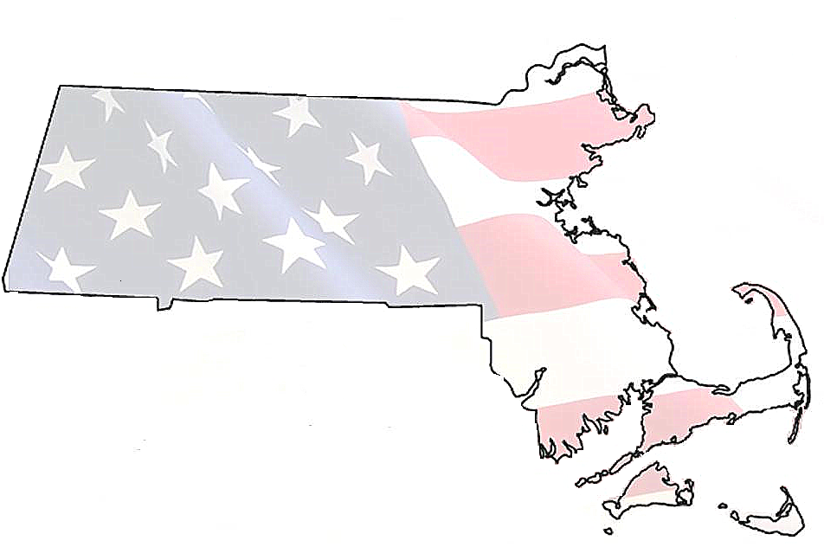


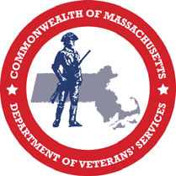

Veterans’ Services Accomplishments

Massachusetts has a proud record as the national leader in veterans’ services. Even during times of economic uncertainty it should be remembered by all of us that veterans of the Commonwealth and nation have sacrificed and served their country and deserve the fine opportunities and benefits they have dutifully earned. The Patrick-Murray Administration values veterans from all eras and their families who serve alongside them, and has made supporting veterans a priority in the Governor’s fiscal year 2014 budget and previous budgets.

Executive Branch Leadership - The Governor’s Advisory Council on Veterans’ Services was re-established by Executive Order in April of 2007. After laying dormant for the previous 12 years before they came into office, Governor Patrick and Lt. Governor Murray chose to reconvene the council in order to give veterans, their family members, and their advocates a seat at the table in the Governor’s Office and Executive Branch. The Council works to review and assess state, federal, and local statutes and programs relating to veterans and their families and the delivery of services to them, including healthcare, education, housing, outreach, training and retraining. Lt. Governor Murray has served as chairman, and worked across party lines with partners in the Federal Delegation, State Legislature, and Municipal Leaders to support those who have served. Specifically, he partnered with members of the Joint Committee on Veterans and Federal Affairs and the members who have deployed: Senator Michael Rush, Representative Hank Naughton, Representative Jerry Parisella, and Former Representative James Vallee. Working together, two pieces of comprehensive legislation to support veterans and military families were passed in 2009 and 2012 and signed into law by Governor Patrick.

Since 2009, Lt. Governor Murray has led an annual Veterans Tour to highlight and promote services and benefits available to veterans and military families. Over the course of a two week period each year, the Lt. Governor participated in numerous tours, meetings, and events supporting and relating to military and veterans’ issues. The goals of the tour were to reach those who have not yet taken advantage of these services; increase public awareness that we are a nation still involved in warzones; and to express thanks to those who have served in the military, honor them for their service, and acknowledge their commitment to defending the country.

Lt. Governor Murray also chairs the Military Asset and Security Strategy Task Force which consults with the Department of Veterans’ Services and the Massachusetts National Guard to ensure the thousands of military personnel and their families who live and/or work on our Commonwealth’s six military bases are getting the support they need.

Supporting our Veterans by Prioritizing Funding - The Department of Veterans’ Services and Soldiers’ Homes in Chelsea and Holyoke have been free from reductions over the past four fiscal years. The Governor’s 2014 budget continues to fund, or increase, service levels for veteran service programs totaling $132.8 million, supporting an increase of approximately 7% over FY13 estimated spending. Over the last six years of the Patrick-Murray Administration, collective funding for the Department of Veterans’ Services and Soldiers’ Homes has increased 47% or $42.5 million in order to continue providing care and services for the rising number of veterans and their families in Massachusetts.

Signature Initiatives

Creating Educational Opportunities and Supports for Student Veterans and Military Children - Lt. Governor Murray established the Military Child Educational Awareness Program, which is an expansion of the Massachusetts National Guard’s successful pilot program for military children in the Massachusetts school system. Also, as part of The VALOR Act, Massachusetts joined more than 40 other states as part of the Interstate Compact on Educational Opportunity for Military Children, improving the transition between schools for the children of military families. The Student Veterans Advisory Board was created and recently held the 1st Annual Student Veterans Appreciation Day. Further, as a result of a directive from Lt. Governor Murray to increase training for veterans’ representatives in all higher education institutions and promote the GI Bill, the Department of Higher Education and the Department of Veteran’s Services released a plan called “Initiatives to Promote Veterans’ Access to and Success in Higher Education” that outlines action steps to make all college campuses more veteran friendly.

Getting our Veterans Back to Work - In 2011, the Patrick-Murray Administration launched an aggressive employment campaign focused on increasing the hiring of Massachusetts veterans. Among these initiatives, the Administration has partnered with major trade associations to encourage them to hire veterans and circulate information on veterans’ benefits. Currently, the Administration is partnering with the Greater Boston Chamber of Commerce’s “Boots to Business” program, which expands mentoring and networking opportunities and educates local employers about the skills service members gain in the military. Over a three year span the Administration received U.S. Department of Labor Grants for Homeless Veteran Reintegration and Training and Workforce Investment for implementation in sites across the state. These grants provided training and placement assistance by which over 960 veterans were placed in long-term position with competitive wages. Also, Veterans receive priority of service at each of the Department of Career Service’s 33 One-Stop Career Centers, which have dedicated veterans’ specific staff that served over 17,000 veterans last year. Further, to lead by example within state government, Governor Patrick and Lt. Governor Murray established the Interagency Taskforce on Hiring Veterans, which released a plan to improve hiring policies, practices, and processes. And in March 2013 in response to a request from First Lady Michelle Obama, Lt. Governor Murray established guidelines to assist members of the armed forces, veterans, and their spouses with professional licenses so they can more easily prepare for, transfer from other states to, and apply for jobs in the Commonwealth.

Creating Opportunities for Disabled Veteran Owned Small Businesses - Following authorization in 2012 of The VALOR Act, Governor Patrick signed an executive order to help small businesses owned by disabled veterans gain access to contracts for public projects in the areas of construction, design and goods and services procurement.

Giving Veterans Access to Information and the Recognition They Earned - Lt. Governor Murray worked with the Department of Veterans’ Services and the Registry of Motor Vehicles to allow veterans the option to receive a Veterans Designation on the front of all MA Driver’s Licenses and State IDs so first responders are aware of their veteran status and veterans can be notified of benefits. Since January 2012, more than 11,000 veterans have received new licenses and IDs. Also, the Department of Veterans’ Services, along with the Massachusetts Technology Collaborative, created the first in the nation veteran web portal www.MassVetsAdvisor.org which is a comprehensive easily searchable website outlining 400+ benefits and programs.

Supporting our Veterans and Military Families in Need - Lt. Governor Murray and the Department of Veterans’ Services developed the Statewide Advocacy for Veterans Empowerment (SAVE) Program and the Statewide Housing Advocacy Reintegration and Prevention (SHARP) Program, which are both first in the nation state programs providing veteran peer to peer support, suicide prevention, and outreach to homeless combat veterans. Since its inception in February 2008, the SAVE team has reached more than 20,000 veterans and family members. The VA has provided $325,000 per year for two years to provide community based outreach treatment to veterans in the Metro Boston area. Additionally, through a partnership with the Interagency Council on Housing and Homelessness, Lt. Governor Murray released the Massachusetts Integrated Plan to Prevent and End Homelessness Among Veterans that will ensure all Massachusetts veterans will have a stable place to call home. Lastly, the MassHousing Home for the Brave Program launched in July 2008 and was a program recommended by the Veteran’s Council’s Subcommittee on Housing. The program offers affordable, no-down payment mortgage financing for veterans of the U.S. Armed Services. Since the program began there have been dozens of loans issued to veterans for more than $5 million in financial assistance.

Women’s Veterans Network and Military Sexual Trauma Working Group - The Women’s Veterans Network (WVN) continues to expand in scope and programming under the direction of Lt. Governor Murray and DVS. This year the WVN will hold its 5th Annual Conference at UMass Boston on June 15. In addition to the conference, the WVN holds a Women Veterans Appreciation Day and numerous programming and outreach events each year. The WVN also provided direct peer support and referrals to over 300 women veterans this past year. Through the Veterans’ Council, Lt. Governor Murray initiated the creation of the Governor’s Task Force on Military Sexual Assault as a collaboration with state, federal and non-profit agencies to raise awareness of resources for survivors of military sexual assault and domestic violence.
The Patrick Administration’s Vision for Action Steps in 2013–2014

- Coordinate across state agencies to ensure the needs of veterans and military families are given the attention they deserve. Increase awareness among the Legislature and the general public of the challenges facing veterans, service members and their families so programming and funding remains at current or expanded levels. We must never lose sight of why we serve those who have fought for us.
- Expand employment initiatives to all regions through the regional chambers of commerce, workforce investment boards, and local and statewide business associations.
- Support Gold Star Families by partnering with them and their organizations, and advocating for their needs and requests.
- Ensure the work done by the Massachusetts Veteran and War Memorial Commission is reviewed and that their recommendations are strongly considered by the Governor and Legislature for implementation to ensure that we support the sites across the Commonwealth and never forget those lost.
- With the Interagency Council on Housing and Homelessness and the Department of Veterans’ Services implement The Massachusetts Integrated Plan to Prevent and End Homelessness Among Veterans and end veterans homelessness by 2015.
- Expand the Department of Veterans’ Services SAVE and SHARP peer support outreach teams. These programs are national models which truly save the lives of veterans.
- With collaboration from the Executive Office of Health and Human Services the Department of Veterans’ Services and the Holyoke and Chelsea Soldiers’ Homes, draft a strategic statewide plan for the long term care needs of veterans to ensure the finest care.
- Partner with the Legislature, the Massachusetts Veterans Service Officers Association and the Massachusetts Municipal Association to ensure we have the most qualified and professional municipal veterans’ agents by standardizing training and confirming compliance with Chapter 115 of the Massachusetts General Laws.
- Under the guidance of the Department of Veterans’ Services and the Department of Higher Education, promote the GI Bill and build on the momentum of the Student Veteran Advisory Board with the goal to expand the reach to every public and private institution in the Commonwealth so our institutions of higher learning become the national model for serving and educating our student veterans.
- Build on the VALOR Act and DHE and DVS’s report to Promote Veterans’ Access to and Success in Higher Education by releasing guidelines to streamline the acceptance of military experience for college credit at all state colleges and universities so the skills of our servicemen and women can more easily transition to the workforce.
- Re-launch the Governor’s Advisory Council on Veterans’ Services with new members and Secretary of Veterans’ Services Coleman Nee as the chair to be the mechanism that coordinates across all partners and agencies to implement these actions.
- Celebrate our success and always honor those who have served!

