GOVERNOR PATRICK URGES EL AL CEO TO CREATE DIRECT FLIGHT FROM BOSTON TO TEL AVIV

Governor also meets with Israeli Chief Scientist Avi Hasson to discuss future collaboration between Israel and Massachusetts
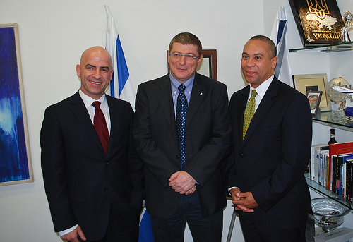

This morning, Governor Patrick met with the CEO of El Al Airlines to advocate for a direct flight between Boston and Tel Aviv. From left to right, Consul General from Israel to New England Shai Bazak, CEO of El Al Airlines Major General Eliezer Shkedi, Governor Patrick. (Photo credit: Alex Goldstein/Governor's Office).
TEL AVIV - Monday, March 7, 2011 - Governor Patrick and members of the Innovation Economy Partnership Mission delegation today met with the CEO of El Al Airlines Major General Eliezer Shkedi in their first meeting upon arrival in Israel this morning. The Governor and delegation members received a briefing from the Major General about the airline, and urged him to consider initiating a direct flight from Boston to Tel Aviv in the coming months. Focusing on the strong business ties between Israel and Massachusetts, as well as the significant Jewish community in the Greater Boston area, the delegates each emphasized the benefits of this direct connection.
"A direct flight between Boston and Tel Aviv would be a tremendously positive development for our many businesses and residents who regularly travel to and from Israel," said Governor Patrick. "It was a very positive meeting and we left with a commitment from El Al to evaluate over the coming months, the feasibility of a direct flight from Boston to Tel Aviv."
Later this afternoon, Governor Patrick and the full delegation met with Israel's Chief Scientist Avi Hasson at the Ministry of Industry, Trade and Labor in Tel Aviv. This meeting was an opportunity to engage directly with Mr. Hasson, who is a critical leader in the State of Israel's support for entrepreneurship and innovation across the country. Delegation members spoke about plans for future collaboration between Israeli and Massachusetts businesses, particularly in the Life Sciences, Information Technology and CleanTech sectors, and discussed the ways in which the two governments could play a role in supporting those partnerships in the future. An announcement to further solidify is expected later this week relative to establishing a framework for future partnerships that support innovation and entrepreneurship in Massachusetts and Israel in the days ahead.
"Massachusetts and Israel share an exceptional commitment to spurring entrepreneurship and growth in our innovation industries, and our meeting with the Chief Scientist reinforced our mutual goals of supporting a vibrant and robust climate for innovation in Massachusetts and Israel," said Governor Patrick. "I look forward to further developing, expanding, and implementing a strong partnership in the next few days."
Governor Patrick and the delegation will meet with the Minister of Industry, Trade and Labor Shalom Simhon on Thursday.
Today there are nearly 100 companies with Israeli founders or Israeli-licensed technologies in Massachusetts. In 2009, these companies employed nearly 6,000 people and generated $2.4 billion in direct revenue for the state. Local firms exported over $180 million worth of goods to Israel in 2009 and, at 12.35 percent, the United States is Israel's largest source of imports.

