GOVERNOR PATRICK JOINS MFA REPRESENTATIVES TO DISCUSS COLLABORATIONS IN THE ARTS AND CULTURAL INDUSTRIES
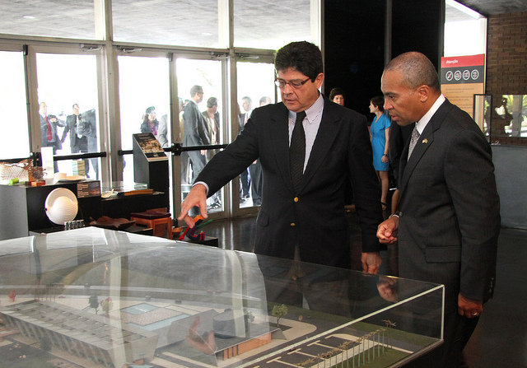
Governor Patrick meets with representatives from the Museum of Modern Art, Rio de Janeiro (Photo Credit: Governor’s Office)
RIO DE JANEIRO, BRAZIL– Thursday, December 8, 2011 - Governor Deval Patrick today joined representatives from the Museum of Fine Arts (MFA) at a roundtable forum hosted by Rio de Janeiro’s Museum of Modern Art (MAM-Rio) to discuss collaboration opportunities for job creation and economic development between Massachusetts’ and Brazil’s arts and cultural industries.
“The Museum of Fine Arts is a cultural jewel in Massachusetts and I am excited to help the MFA build partnerships with their Brazilian counterparts,” said Governor Patrick. “This will lead to additional opportunities to grow jobs, tourism and partnerships in our thriving cultural sectors.”
“The MFA is delighted to participate in the Massachusetts Brazil Innovation Economy Mission, which offers us the opportunity to explore potential cultural collaborations with a country that has a rich artistic heritage and a vibrant contemporary art scene. This is especially important because of the Museum’s new Art of the Americas Wing, where we can now showcase a greater number of works from Latin America,” said Maria Muller, MFA’s deputy director. “Additionally, Massachusetts has a large Brazilian and Portuguese-speaking population and we hope to also establish stronger ties to this dynamic community.”
Like the MFA, MAM-Rio is a private institution with an impressive international collection. During the 1950’s and 1960’s, MAM-Rio was the birthplace of the most important avant-garde and experimental art movements in Brazil.
The MFA, the only cultural organization in the delegation, is represented by Muller and Dennis Carr, curator of decorative arts and sculpture at the MFA.
During the Massachusetts Brazil Innovation Economy Mission, the MFA has focused on three specific areas of exchange: curatorial, scholarship and community. Muller and Carr have met with representatives from museums and other cultural organizations from throughout Brazil to develop sustainable global partnerships.
From December 4-9, 2011, the Innovation Economy Mission will make stops in Brasília, São Paulo and Rio de Janeiro, visiting Brazilian companies, universities and government leaders to highlight all that Massachusetts has to offer to Brazil. The mission will focus on creating jobs in the life sciences, IT, clean energy, financial services and education sectors, while solidifying the already strong Massachusetts-Brazil connection. Prior to arriving in Brazil, Governor Patrick and a smaller delegation traveled to Chile December 1-2 at the request of President Sebastian Piñera and signed an agreement to grow jobs and opportunities in the areas of clean energy, biotechnology and education.

