GOVERNOR PATRICK MEETS WITH PRIME MINISTER BENJAMIN NETANYAHU, OTHER KEY LEADERS IN JERUSALEM
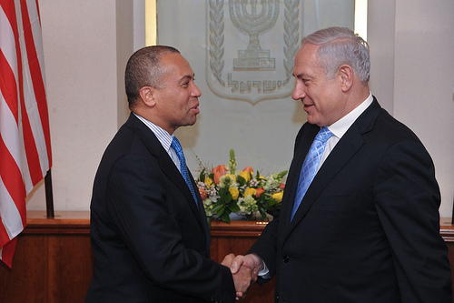

Governor Patrick meets with Benjamin Netanyahu, Prime Minister of the State of Israel in Jerusalem. (Photo credit: Amos BenGershom /Prime Minister's Office).
Jerusalem - Wednesday March 9, 2011 - Massachusetts Governor Deval Patrick today met with top Israeli leaders, including Prime Minister Benjamin Netanyahu and Chairperson of the Opposition Tzipi Livni, in Jerusalem to discuss economic opportunities as part of the Massachusetts Innovation Economy Partnership Mission 2011.
"Our delegation from Massachusetts brings with it a message of collaboration, friendship, and steadfast support of the State of Israel," said Governor Patrick. "Our shared values of innovation, entrepreneurship, and generational responsibility bind us closely. Our delegation looks forward to working in partnership in the days ahead with the many Israeli government officials and business leaders we meet with on this trip to build a better and stronger Commonwealth and State of Israel for generations to come."
Benjamin Netanyahu is Prime Minister of Israel, serving since March 2009. He also serves as the current Chairman of the Likud Party. He has previously served as Israel's ambassador to the UN, deputy chief of mission at the Israeli Embassy in Washington, DC, Deputy Minister of Foreign Affairs, and head of opposition before his first election as Prime Minister of Israel in 1996. He is a former commander in the Israeli Defense Forces.
Tzipi Livni is Chairperson of the Opposition. Livni was a member of the Likud Party until the end of 2005, when she, together with other prominent political figures in Israel, formed the Kadima Party. In 2008 she was elected chairman of Kadima. In 2006 Livni was appointed Vice Prime Minister and Minister of Foreign Affairs in the 31st Government of Israel, serving until 2009. She also served as Minister of Justice. She served as an officer in the IDF, and later in the Mossad.
In Jerusalem, Governor Patrick also met with Deputy Foreign Minister Danny Ayalon and Deputy Prime Minister Dan Meridor to discuss strategies to grow the innovation economy sectors in Israel and Massachusetts. Earlier in the day, Governor Patrick met with the Mayor of Haifa, Yona Yahav; visited students at Haifa University; and met with University President Aaron Ben-Ze'ev, before participating in an Innovation Economy Town Hall Meeting at Technion - Israel Institute of Technology.
See more photos from Governor Patrick's meetings in Israel: http://www.flickr.com/photos/massgovernor/sets/72157626216299940/
Today there are nearly 100 companies with Israeli founders or Israeli-licensed technologies in Massachusetts. In 2009, these companies employed nearly 6,000 people and generated $2.4 billion in direct revenue for the state. Local firms exported over $180 million worth of goods to Israel in 2009 and, at 12.35 percent, the United States is Israel's largest source of imports.
The Massachusetts Innovation Economy Partnership Mission 2011 is focusing on business expansion, job growth and collaboration during industry forums, company visits and meetings with Israeli and U.K. business leaders and government officials in Tel Aviv, Haifa, Jerusalem, London and Cambridge. The Massachusetts delegation arrived in Israel on March 7th, and will depart the United Kingdom on March 17th to return to Boston.

