GOVERNOR PATRICK AND SANTANDER CEO ANNOUNCE MASSACHUSETTS-BRAZIL UNIVERSITY EXCHANGE PROGRAM

Santander to fund seven university research projects in 2012
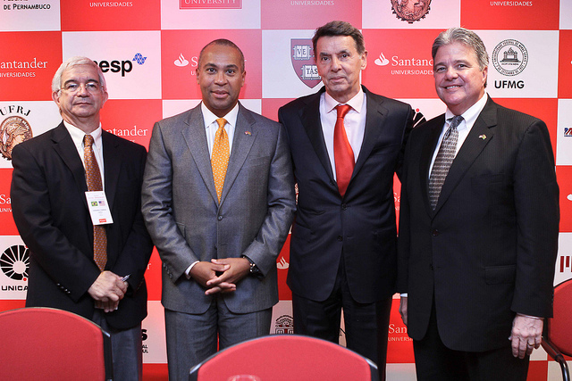
President of University of Campinas Fernando Ferreira Costa, Governor Deval Patrick, Santander President and CEO Marcial Portela and UMass President Robert Caret announce the TOP USA-Massachusetts Program. (Photo: Nádia Maekawa Bellagamba)
São Paulo, Brazil - Wednesday, December 7, 2011- Governor Deval Patrick today joined President and CEO of Santander Brazil Marcial Portela to announce the TOP USA-Massachusetts Program, an initiative that will promote an academic exchange of faculty and students between several Brazilian and North American Universities, including the University of Massachusetts (UMass) system.
Through the TOP USA-Massachusetts Program, Banco Santander will fund seven projects per year for faculty, post-doctorate and graduate students to study at partner universities in each country. Each project can include up to four individuals - one Brazilian faculty leader and one researcher/ graduate student and one American faculty leader and one researcher/ graduate student. Banco Santander will fund faculty member exchanges from Brazilian and American universities for up to fifteen days and graduate student, postdoctoral student or researcher exchanges for up to two months.
“Massachusetts is home to many of the foremost research universities in the world,” said Governor Patrick. “We are delighted to partner with these Brazilian institutions to expand that reach and broaden our research platform even further with this partner nation.”
The participating North American universities include the University of Massachusetts, Boston University, Brown University, Harvard University, Massachusetts Institute of Technology and Northeastern University. The participating Brazilian Universities include Universidade Federal de Minas Gerais, Universidade Federal de Pernambuco, Universidade Federal do Rio Grande do Sul, Universidade Federal do Rio de Janeiro, Universidade de São Paulo, Universidade Estadual Paulista and Unversidade Estadual de Campinas.
For the president of Banco Santander, Mr. Marcial Portela, the work done by the Santander Universities has won visibility among the high education institutions by having a single model of operation, unprecedented in the world. "We built a close relationship with 979 universities in 16 countries around the world, during these 15 years of work," said President of Banco Santandar Marcial Portela. "To invest in an International Mobility Program as the TOP USA-Massachusetts is a great satisfaction for us, to promote the knowledge exchange between faculties from Brazil and USA."
“This initiative between Santander and six of the most relevant universities in Brazil represent 17,000 researchers and professors that are responsible for 60 percent of the researches done in our country," said Dean of University of Campinas Fernando Ferreira Costa. "We are very pleased to be part of this exchange program that connects us with some of the most relevant universities in the USA. The UNICAMP feels very proud to be coordinating the TOP USA-Massachusetts and hopes that this partnership lasts for the next 20 years and so."
“Exchange programs build bridges between universities and between people and I commend Banco Santander for having the vision and generosity needed to create this very important program,” said University of Massachusetts President Robert L. Caret. “This program will create tremendous opportunities for UMass students and faculty to study and work in Brazil and I likewise look forward to welcoming partners from Brazil to our campuses. I know that this program will pay enormous dividends over the years and will build new and enduring bonds between Massachusetts and Brazil. I very much appreciate Banco Santander’s bold action and Governor Patrick’s role in nurturing this initiative.”
The program will provide financial support to every participating Brazilian university, as well as fund participating North American universities. Project proposals from participating universities are due in March 2012 and will be reviewed by a commission comprised of representatives from Santander and the University of Campinas. Awardees will be selected by April 2012 and projects must be completed by the end of the year.
In addition to being selected for the TOP USA-Massachusetts Program, the UMass Amherst and Dartmouth campuses have also been selected to participate in the Institute of International Education’s 2012 International Academic Partnership Program in Brazil. These institutions were two of only 18 colleges and universities across the country selected for this partnership back in November.
Earlier this year, Brazilian President Dilma Rousseff committed to sending 75,000 Brazilian students abroad over the next four years through its Science Without Borders Program, a scholarship program for Brazilian students focusing on the STEM fields (Science, Technology, Engineering and Mathematics) to study at the world’s best universities. As an international leader in the STEM fields, Massachusetts is well positioned to compete for thousands of international students to study in the Commonwealth next year.
As part of the International Academic Partnership Program, both UMass Amherst and UMass Dartmouth will establish a campus-wide task force to work on prospective partnerships, conduct an institution-wide inventory of activities pertaining to Brazil and develop a strategic plan focused on partnership with Brazil.
From December 4-9, 2011, the Innovation Economy Mission will make stops in Brasília, São Paulo and Rio de Janeiro, visiting Brazilian companies, universities and government leaders to highlight all that Massachusetts has to offer to Brazil. The mission will focus on creating jobs in the life sciences, IT, clean energy, financial services and education sectors, while solidifying the already strong Massachusetts-Brazil connection. Prior to arriving in Brazil, Governor Patrick and a smaller delegation traveled to Chile December 1-2 at the request of President Sebastian Piñera and signed an agreement to grow jobs and opportunities in the areas of clean energy, biotechnology and education.

