GOVERNOR PATRICK SWEARS IN NEW CHIEF JUSTICE OF THE MASSACHUSETTS SUPREME JUDICIAL COURT
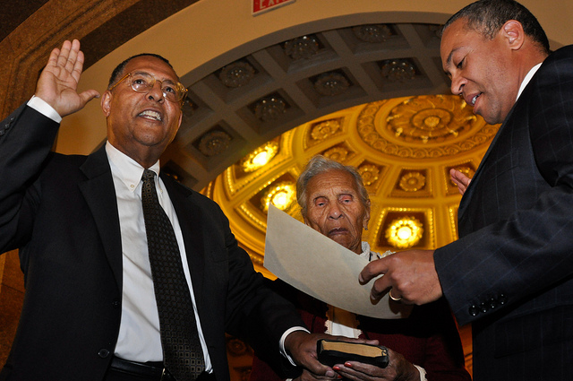
Yesterday, Governor Patrick swore in Roderick L. Ireland as Cheif Justice of the Massachusetts Supreme Judicial Court. (Photo Credit: Matt Bennett/Governor's Press Office)

BOSTON - Monday, December 20, 2010 - Governor Deval Patrick today swore in Senior Associate Justice Roderick L. Ireland as the new Chief Justice of the Massachusetts Supreme Judicial Court. Justice Ireland is the first person of color to lead the Supreme Judicial Court and the Judiciary, the third branch of government, and fills the vacancy created by the retirement of Chief Justice Margaret H. Marshall.
"This is a momentous and historic occasion for our Commonwealth, and I am confident that Justice Ireland's tenure as Chief Justice will reflect the strengths he has brought to the bench for three decades - sharp intellect, sound judgment, and proven fairness," said Governor Deval Patrick.
A native of Springfield, Massachusetts, Justice Ireland has given a lifetime to public service. He has served the Commonwealth as a member of the judiciary for over three decades, beginning with his 1977 appointment to the Boston Juvenile Court. After thirteen years on the Juvenile Court, he became an Associate Justice of the Appeals Court in 1990. In 1997, Governor William F. Weld nominated him to the Supreme Judicial Court, where he became the first person of color to serve that distinguished court in its more than 300 year history.
Justice Ireland's extensive legal career prior to joining the bench includes experience as a legal services staff attorney in New York City, a staff attorney for the Harvard Center for Law and Education, an attorney and Executive Director of the Roxbury Defenders Committee, General Counsel and Assistant Secretary of the Massachusetts Executive Office for Administration and Finance, and Chair of the Massachusetts Board of Appeal on Motor Vehicle Liability Policies and Bonds. He has taught courses in law and criminal justice for over 30 years, and has been recognized by many organizations for his judicial excellence and service. Justice Ireland is a graduate of Lincoln University (BA, 1966), Columbia Law School (JD, 1969), Harvard University Law School (LLM, 1975), and Northeastern University: Law, Policy and Society Program (PhD, 1998).
During today's ceremony, Governor Patrick also thanked retired Chief Justice Marshall for her leadership, her diligence, her vision and her devotion to the Commonwealth's judicial system. Justice Ireland will carry on her work and continue to move the judiciary and the people it serves forward into the 21st Century.
Justice Ireland is Governor Patrick's third appointment to the state's highest court, following his prior appointments of Justice Margot G. Botsford and Justice Ralph D. Gants.

