GOVERNOR PATRICK ATTENDS PRIME MINISTER QUESTIONS; MEETS WITH BRITISH-AMERICAN PARLIAMENTARY GROUP
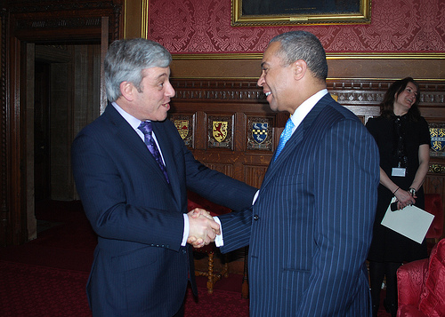
Massachusetts Governor Deval Patrick meets with Speaker of the House of Commons John Bercow, MP, during a British-American Parliamentary Group reception in London. (Photo credit: Matthew Campion / British Consulate-General Boston). View additional photos.
LONDON -- Wednesday, March 16, 2011 - Massachusetts Governor Deval Patrick today attended Prime Minister Questions, led by Prime Minister David Cameron at the House of Commons, and attended a British-American Parliamentary Group reception, hosted by Speaker of the House of Commons John Bercow, MP, to discuss job-growth opportunities between Massachusetts and the UK. The visits are part of the Massachusetts Innovation Economy Partnership Mission 2011, which has included several industry forums, company visits, and meetings with Massachusetts and UK officials throughout the course of the week.
About Prime Minister Questions:
Led by Prime Minister David Cameron, Prime Minister Questions are usually arranged in advance by organizers of each party, but many questions will be asked without notice. Members of Parliament are permitted to ask a total of six questions. The Leader of the Opposition, Ed Miliband of the Labour Party, is the only Member of Parliament who can come back with further questions. Prime Minister Questions are the most well-known component of Parliamentary business and are broadcast live on British television and on C-SPAN in the U.S. The sessions take place on Wednesdays at 12 p.m.
About the British-American Parliamentary Group:
The British-American Parliamentary Group consists of about 655 members from both Houses of Parliament with Prime Minister Cameron as its Chairman. Its mission is to strengthen the relationship between Members of Congress in Washington and Parliamentarians and Peers in Westminster. It has also helped foster cooperation between the two countries. During the event, hosted by Speaker Bercow, Governor Patrick met with several Members of Parliament, including Mike Freer and Sajid Javid from the Conservative Party, and Austin Mitchell and Rachel Reeves from the Labour Party who attended a Harvard University Institute of Politics course for newly elected Members in September 2010. Earlier today, Governor Patrick also met with several Members of Parliament in London to discuss growing economic opportunities between the UK and Massachusetts.
On Monday, Governor Patrick and his delegation of Massachusetts business leaders and government officials met with IT sector leaders at the London Stock Exchange to establish partnerships to accelerate job growth and investment in the technology sector. The Governor also led a roundtable discussion with leading financial services firms at Mansion House, met with executives at Lloyd's of London, and received a briefing from the US Ambassador to the UK. On Tuesday, the Governor oversaw the signing of an agreement between the UK Stem Cell Bank and the University of Massachusetts to share best practices for stem cell research. Governor Patrick then travelled to Granta Science Park in Cambridge where he led a roundtable discussion on UK-Massachusetts collaboration in the life sciences, and held a town hall meeting at the Institute for Manufacturing. Governor Patrick later paid his respects to WWII service members at the Cambridge American Cemetery and Memorial.
The Massachusetts Innovation Economy Partnership Mission 2011 is focusing on business expansion, job growth and collaboration during industry forums, company visits and meetings with Israeli and UK business leaders and government officials in Tel Aviv, Haifa, Jerusalem, London and Cambridge. The Massachusetts delegation arrived in the UK on March 12 and will return to Boston on March 17.
Read more about the Innovation Economy Mission:www.mass.gov/governor/innovationmission.

