GOVERNOR PATRICK SIGNS TRANSGENDER EQUAL RIGHTS BILL

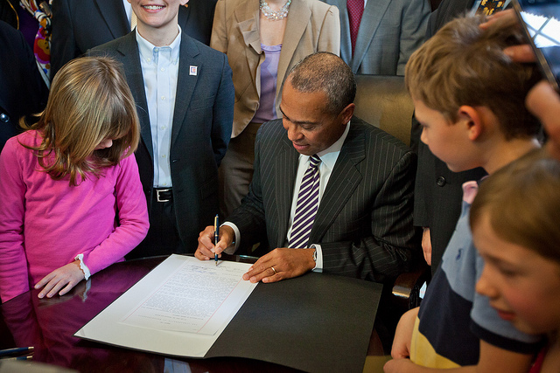
Governor Patrick joins advocates and legislators for a ceremonial bill signing of H.3810, “An Act Relative to Gender Identity.” (Photo: Eric Haynes/Governor's Office). View additional photos.
BOSTON - Wednesday, November 23, 2011 – Governor Deval Patrick today signed H.3810, “An Act Relative To Gender Identity," historic legislation to legally protect transgender individuals from discrimination in housing, education, employment and credit. The new law, signed at the State House today, also provides additional civil rights and protections from hate crimes.
“No individual should face discrimination because of who they are,” said Governor Patrick. “This legislation gives Massachusetts the necessary tools to stop hate crimes against transgender people and to treat others fairly. I am proud to sign it.”
“Massachusetts strives to be an inclusive Commonwealth, and this new law acknowledges that discrimination against any person will not be tolerated,” said Lieutenant Governor Timothy Murray.
The transgender equal rights law will make Massachusetts the 16th state to treat transgender citizens as a protected class. The law modifies language in Massachusetts statute to protect all individuals from discrimination, regardless of gender identities. This change will create equal protections for transgender individuals seeking employment, housing, credit and education. There are approximately 33,000 transgender residents living in Massachusetts.
The new law will also increase the state’s ability to prosecute criminal conduct in the form of hate crimes against transgender individuals, a community that has historically experienced disproportionate levels of harassment and violence.
“Today is a another step toward ensuring equal protections for all citizens and eradicating discrimination in our Commonwealth,” said Attorney General Martha Coakley. “For too long, transgender people have suffered in silence in seeking employment, safe housing and educational opportunities. With the signing of this bill, Massachusetts has created a better, and fairer, future for all residents, regardless of their gender identity or expression.”
"This bill provides protection in employment, housing, credit and education to transgender people," said House Speaker Robert A. DeLeo. "I am proud that Governor Patrick is supporting this important civil rights milestone."
"This bill is about making sure that our anti-discrimination and civil rights laws protect all victims,” said Senator Benjamin B. Downing. “For too long the 33,000 transgender residents in Massachusetts have gone without these protections. Thanks to this step that will no longer be the case.”
“The passage of this bill is going to make an immediate difference in the lives of the state’s transgender residents, who desperately need anti-discrimination protections in housing and employment. I have been so moved by the courage of constituents who’ve shared their stories with lawmakers and shown the critical need for these civil rights protections,” said Representative Carl Sciortino. “I am incredibly grateful for the leadership shown by Governor Deval Patrick and House Speaker Robert DeLeo, both early supporters of the bill, as well as that of House Judiciary Chair Eugene O’Flaherty and my fellow House sponsor State Representative Byron Rushing. And, of course, I am grateful to all of my colleagues who voted for passage of this important legislation. With the passage of this legislation, we have taken an important step forward in making Massachusetts a better place for all of its residents.”
“Governor Patrick has been a powerful, eloquent and determined champion of lesbian, gay, bisexual and transgender equality, and we applaud him for signing the Transgender Equal Rights Bill. Leading up to today’s signing, Governor Patrick’s campaign platform called for transgender equality; he transformed our state government in the early days of his second term with an executive order prohibiting anti-transgender discrimination in state hiring practices; and he used his leadership post to speak out early, often and everywhere about the need for justice and equality for everyone in our Commonwealth, including our transgender community members,” said MassEquality Executive Director Kara Suffredini. “We are grateful for Governor Patrick's latest action in a long-standing effort to create a Commonwealth where all hardworking people, including transgender people, have the opportunity to make a living, put a roof over their heads and get an education without fear of being discriminated against simply because of who they are.”
“I greatly appreciate Governor Patrick’s leadership and commitment to transgender youth, adults and their families in being treated fairly and equally in this state by his swift signing of this bill,” said Gunner Scott, executive director of the Massachusetts Transgender Political Coalition. “This law will make a significant difference in the lives of transgender youth and adults across the state who need jobs, a safe place to live and a quality education.”

