Office of The Governor
The Commonwealth of Massachusetts
state house boston, ma 02133
(617) 725-4000

MASSACHUSETTS: A NATIONAL MODEL FOR HEALTH CARE REFORM
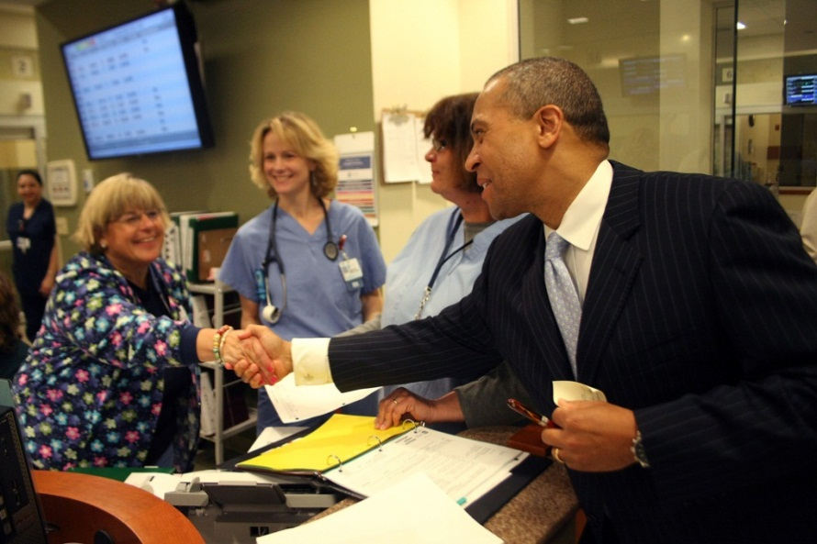
Massachusetts today is proof that health care reform works. Reform has helped achieve real savings and makes us more competitive in the global economy. That’s why Massachusetts is proud to be a model for President Obama’s Affordable Care Act.
Bay State Success Story:
- Thanks to the 2006 reform, which was successfully implemented by the Patrick-Murray Administration, more than 98 percent of Massachusetts residents have health care coverage, including 99.8 percent of children. No other state in America can touch this.
- Private companies offering health insurance to their employees is up to 77 percent from 70 percent before reform was implemented. That’s nearly 10 percent higher than the national average.
- A recent survey found more than 80 percent of Commonwealth Care members are satisfied with their coverage. Four in five have seen a doctor during the last year and more than 90 percent have a primary care provider.
- Health care reform is not a budget buster. Universal coverage has added only about 1 percent to our budget in state spending.

Cracking the Code on Costs:
The challenge of high health care costs is not unique to Massachusetts and has nothing to do with Massachusetts health care reform. Escalating premiums in America over the last decade is one of the greatest challenges for businesses, governments and working families across the country.
Limiting Health Insurance Rates: To address the issue of double-digit premium increases, Governor Patrick directed the Division of Insurance to reject unreasonable and excessive rate increases, resulting in more than $100 million in savings for consumers.

Next Phase of Reform: Governor Patrick in now leading the charge to adopt integrated, whole person care. This model would pay providers for the quality of health care they deliver, not just the quantity. The Administration’s goal is for integrated, cost-efficient caregivers to predominate in Massachusetts by 2015. The Administration will ensure these savings are passed along to families, businesses and government in the form of lower premiums.
Top Legislative Priority: Governor Patrick and Lieutenant Governor Murray have visited numerous hospitals and clinics to discuss these reforms with medical professionals and patients directly. Governor Patrick also testified before the U.S. Senate Finance Committee’s health care forum in Washington, D.C. on these reform efforts. Health care cost containment is Governor Patrick’s number one legislative priority and the Legislature should act to adopt these changes as soon as possible to help businesses and working families.

