GOVERNOR PATRICK MEETS WITH U.S. AMBASSADOR TO BRAZIL AND BRAZILIAN GOVERNMENT LEADERS
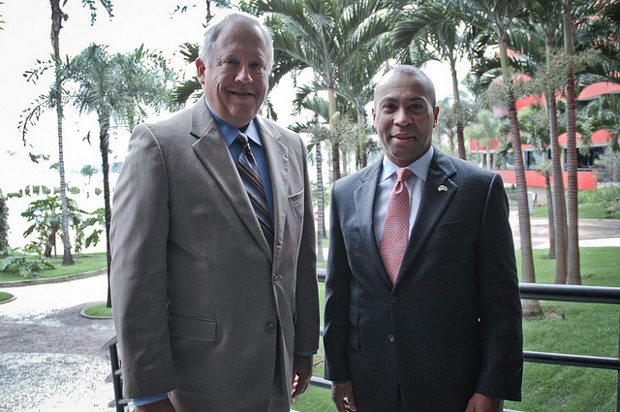

Governor Patrick meets with U.S. Ambassador to Brazil Thomas Shannon. (Photo credit: Governor's Office)
BRASILIA, BRAZIL -- Monday, December 5, 2011 -- Governor Deval Patrick today kicked off the Massachusetts Brazil Innovation Economy Partnership Mission 2011, meeting with U.S. Ambassador to Brazil Thomas Shannon and senior government leaders in Brasilia to discuss job creation opportunities.
From December 4-9, 2011, the Innovation Economy Mission is making stops in Brasilia, Sao Paulo, and Rio de Janeiro, visiting Brazilian companies, universities and government leaders to highlight all that Massachusetts has to offer to Brazil. The mission is focusing on creating jobs in the life sciences, IT, clean energy, financial services and education sectors and solidifying the already strong Massachusetts-Brazil connection.
Following the meeting with Ambassador Thomas, Governor Patrick is scheduled to discuss economic partnership opportunities with senior government officials, including: Brazilian Minister of Science, Technology and Innovation Aloizo Mercadanta Oliva; Brazilian Minister of Foreign Affairs Antonio Patriota; and Brazilian Minister of Mines and Energy Edson Lobao.
Prior to arriving in Brazil, Governor Patrick and a smaller delegation traveled to Chile December 1-2 at the request of President Sebastian Piñera and signed an agreement to

