Governor Patrick has managed state finance responsibly and effectively during some of the most challenging fiscal times in generations, while still working to create growth and opportunity throughout the Commonwealth. He has maintained balanced budgets by thoughtfully prioritizing among public investments and making government work more efficiently. Under his fiscal leadership, the Commonwealth has secured the highest bond ratings in its history.

Patrick Administration Record of Fiscal Responsibility and Reforms
Throughout his Administration, Governor Patrick has been focused on changing the way government does business and has implemented numerous reforms and savings initiatives across state government.

Developing and Managing Budgets that are Structurally Balanced – The Patrick Administration was the first to develop and publish a Long-Term Fiscal Policy Framework to ensure that budgetary decisions are informed by long-term financial forecasts and policies that support fiscal sustainability. Governor Patrick has further secured the enactment of laws that transfer volatile capital gains tax revenues in excess of statutorily designated thresholds into the Stabilization Fund instead of relying on them for ongoing budget needs. The Governor’s FY 2015 budget cuts the state’s use of Stabilization Funds (and reduces the net use of other one-time resources) to support annual spending in half from FY 2014, and the Stabilization Fund is forecasted to end FY 2015 at $1.2 B, basically level to the prior year’s balance.

Containing Health Care Cost Growth – The rising costs of health care are one of the most challenging fiscal problems today. The Patrick Administration’s groundbreaking efforts to contain health care costs have bent the health care cost curve; health care cost control legislation is expected to reduce costs in the Massachusetts private health care sector by $200 B over the next 15 years and has saved over $1.7 B since FY 2009 on state health care costs at MassHealth, Commonwealth Care and state employee health insurance programs. Through Municipal Health Reform, the Group Insurance Commission (GIC) has opened its doors to cities and towns to participate in the state health insurance program. Since the Administration proposed Municipal Health Reform in January 2011, more than 240 municipalities and regional school districts came to agreements with employees, achieving premium savings (by changes in local plans or through joining the GIC) totaling more than $230 M.

Addressing our Long-Term Liabilities – Governor Patrick secured enactment of pension reform legislation to help curb the most egregious abuses, change the system to make it more fair and equitable for taxpayers and all state workers, make the pension system more sustainable and credible over time and help restore the public’s trust in state and municipal retirement systems. Pension reform will save the state and its cities and towns $5 B over the next 30 years, and retiree health benefit reform legislation proposed by the Governor would save an additional $20 B. The Governor’s FY 2015 budget significantly increases the state’s annual contribution toward its pension liabilities, as part of a framework jointly endorsed by the Administration and the Legislature to accelerate the full funding of these costs. Working with government and labor leaders, the Administration developed a proposal pending before the Legislature to address the state’s huge, underfunded retiree health care liability, while maintaining this benefit for career public employees. This Administration has also created and is on track to deposit $180 M (since FY 2013) into a State Retiree Health Benefit Trust Fund to begin to address our unfunded retiree health benefit liability. Finally, the Patrick Administration is the first to develop and publish a Debt Affordability Policy to responsibly constrain borrowing to affordable levels and is the first to publish a Five-Year Capital Investment Plan based on this policy.

Executing Policy-Driven Reforms Yielding Savings – Reform initiatives to date include:
- Sentencing Reform will improve public safety by focusing limited public dollars and prison cells on habitual violent offenders. In the long-run, this reform contains the growth in the number of inmates housed in Massachusetts prisons and reduces the need for future construction of 10,000 new prison bed-spaces over 30 years, which would have cost between $1.3 and $2.3 B to build and an additional $3 B in operating costs over 30 years.
- The Accelerated Energy Program is renovating state buildings to reduce energy and water consumption. These construction projects will save over $1.2 B in utility costs over 30 years.
- Procurement Reform has allowed the Commonwealth to strategically leverage its purchasing power to save $65 M since FY 2009.
- Transportation Finance Reform modernized employee benefits and took other steps toward further efficiencies that have saved the Commonwealth over $525 M to date.

Making State Government More Results-Oriented, Data-Driven and Accountable – The Patrick Administration has made great progress in making more information on government spending, revenue and performance publicly available. Publishing online the statewide use of the $7 B in federal American Recovery and Reinvestment Act (stimulus) funds that Massachusetts received was an important step towards improving public accountability. The subsequent launch of Open Checkbook in 2011, a website that provides the public with easy and searchable access to more than 85% of state government spending and tax credit information, built on that foundation of transparency. These actions have earned Massachusetts an A- on Transparency from the U.S. Public Interest Research Group (U.S. PIRG), a 2nd in the nation rating. The Patrick Administration has also worked to improve tracking of federal grants that state government receives to ensure effective use of these funds.

Governor Patrick will release for the first time with his FY 2015 budget:
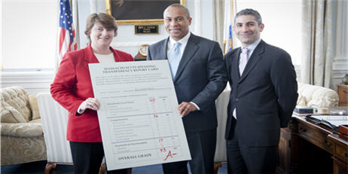
- Secretariat Performance Reports – For the first time in Massachusetts state government history, each of the eight Executive Branch Secretariats has published a performance report alongside the Governor’s FY 2015 budget to update the public with data that evidences progress toward achieving the goals each Secretariat identified in their strategic plans, published with the FY 2014 Budget Recommendation.
- Performance-Based Program Budgeting – The Governor’s FY 2015 budget is presented again in a more accessible and easy-to-understand program-based format, and this year includes specific performance measures and evidence of progress toward those measures, where available, for a majority of budgetary programs. This is part of changing the budget conversation from our traditional focus on how much state government spends to one that is equally concerned with the results produced by that investment. During the year, further and more current data will be added to the dashboard and further measures will be developed.
Governor Patrick displays the Commonwealth’s Transparency Scorecard.
Source: Executive Office for Administration and Finance

In the Governor’s FY 2015 Budget, the Patrick Administration is announcing further initiatives to improve government efficiency and effectiveness while producing cost savings.

Information Technology Reform
Information Technology (IT) enables the delivery of critical services to constituents in a better, faster and more efficient manner than would otherwise be possible. Governor Patrick issued Executive Order 510 in 2009, and Executive Order 532 in 2011, to improve IT service levels and increase efficiency while reducing IT cost escalation. To date, the Commonwealth has achieved $14.4 M in savings from IT consolidation.

Information Technology Consolidation

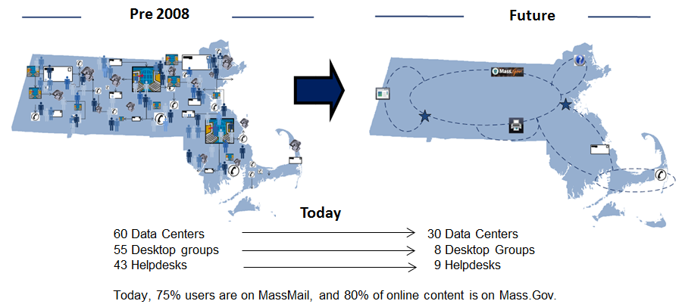
Source: Information Technology Division

While the Administration has made progress toward efficiently operating Commonwealth IT, government and the private sector are learning lessons about how to be more strategic and successful in selecting, procuring and overseeing the implementation of IT projects. An emerging set of “best practices” – focused on even more centralized oversight and accountability and more rigorous up front evaluation of underlying business needs and project strategies – informs a next set of IT reforms being implemented by the Patrick Administration:
DRIVERS OF GOVERNMENT IT NEEDS
- Modern technology improves our ability to provide better, more efficient services at lower cost to taxpayers; we are now using significantly more data, devices, bandwidth and IT systems on a day to day basis.
- With increasing cyber security threats, we need to better protect taxpayer data and to provide resilience through the Springfield Data Center.
- We continue to replace and repair hardware and software that is obsolete and no longer fits our needs. Traditional government funding and procurement practices are at odds with the high speed at which IT solutions evolve.
- We have launched many truly transformational projects such as I-CORI, Commonwealth Connect and Commuter Rail mTicketing. These projects have significantly improved government efficiency and citizens’ ability to hold their government accountable, but require IT support staff to maintain.
- Commonwealth Chief Information Officer (CCIO)
– Elevating the role of the CCIO to provide strategic oversight of IT projects and underlying state business decisions.
- Strategic IT Procurement – Launching a new Strategic IT Procurement Team to improve internal IT project planning capability, bring more diverse vendors into the mix and identify high-value bidders. The goal of this team is to reduce onerous requirements which lead to extended timelines for project completion and implementation of dated technology, as well as to improve competition for the Commonwealth’s IT business.
- Reforming Bulk IT Procurement – Implementing a new IT procurement framework to enhance competition and disqualify underperforming vendors.
- Strategically Selecting IT Projects – Improving the IT capital project selection process to weed out projects that are high risk and have a low return on investment. Using a new tool to measure return on investment and likelihood of success, an IT Portfolio Oversight Committee will oversee IT project selection in a strategic way to develop a portfolio strategy, review ongoing projects, provide transparency into the portfolio planning process, flag “at risk” projects and oversee corrective action.
- Modernizing Commonwealth IT Workforce Practices – Using partnerships with higher education institutions to create a pipeline of talented IT professionals in Massachusetts and implementation of HR Modernization (below) reforms to meet evolving IT business needs.

Interagency Data Services
The Patrick Administration is similarly committed to utilizing technology to create efficiencies and to save taxpayer money. Safety net agencies spend time and resources to verify that those who apply for their services are eligible, using authorized data that is maintained by other agencies. Under the current or old model, the Department of Revenue exchanges large batches of data with agencies, including wage information, bank match information and 14-day new hire information, which is used to verify an applicant’s eligibility for various Commonwealth programs.

The Patrick Administration has introduced a new Interagency Data Services (IDS) model, which is a secure web-based service that provides targeted data verification for authorized agencies, reducing the need for large batch file exchanges of important data files. This enhanced business model will provide authorized agencies with access to targeted information necessary to validate required program business rules, thereby allowing more effective detection and prevention of fraud, waste and abuse across government programs. The state could save $20 M annually by reducing instances of fraudulently acquired services.

Integrated Facilities Management

Upon taking office in 2007, the Patrick Administration inherited public infrastructure that had suffered a generation of underinvestment. Agencies lacked incentives to adequately fund building care and maintenance as they made difficult choices to support public services with limited resources, often at the expense of public assets. Through the Capital Investment Plan, the Patrick Administration has taken steps to reverse this pattern of underinvestment and reduce the deferred maintenance backlog. Integrated Facilities Management (IFM) puts in place a structure to protect that investment by transferring responsibility for building maintenance to the Division of Capital Asset Management and Maintenance (DCAMM) to ensure that facilities are overseen and maintained properly into the future.
Source: Division of Capital Asset Management and Maintenance
Springfield Data Center

Under the direction of DCAMM, IFM has been successfully instituted in several state office buildings, and in one of DCAMM’s key buildings has generated $736,000 in net savings, after investing in immediate deferred maintenance needs. Savings have been achieved through enhanced maintenance standards, improved space utilization, consolidation of utilities and service contracts, a modernized facility workforce and energy savings as a result of the Accelerated Energy Program (described above). As IFM expands to include more state buildings, further taxpayer savings will be achieved, with a long term goal of saving 10% of building operating costs.

In the FY 2015 budget, the Patrick Administration has created a sustainable budgetary framework to embed IFM in state government and devised a “rent” methodology for state buildings to set appropriate space utilization incentives and in the future reduce external lease costs by moving more agencies into state-owned space. Governor Patrick’s continued support of this program in FY 2015 will allow agencies to return their focus to their core mission of serving their populations and ensure that the Commonwealth’s assets are maintained properly into the future.

Human Resources Modernization
The Commonwealth is the largest employer in the state, managing about 40,000 Executive Branch employees alone. Managing such a large number of employees in a way that maximizes taxpayer benefit is critical to government success. In 2010, Governor Patrick issued Executive Order 517, directing the Human Resources Division to improve administrative efficiency and effectiveness by modernizing and standardizing human resources business processes and by leveraging technology to reduce costs. In 2012 and 2013, the Patrick Administration successfully implemented automated timesheets which has reduced by 61% the number of manual transactions completed on this human resources function. Through the Governor’s FY 2015 budget, the Administration will develop a Commonwealth Workforce Plan, highlighting the common needs and remedies needed to effectively address our aging workforce.

http://www.mass.gov/bb/cap/fy2013/exec/hreport_10i.htm

