GOVERNOR PATRICK ANNOUNCES NEW STRATEGIES TO CLOSE PERSISTENT ACHIEVEMENT GAPS IN EDUCATION

Next steps to focus on Gateway Cities, building on success of Governor’s landmark 2010 Achievement Gap Act
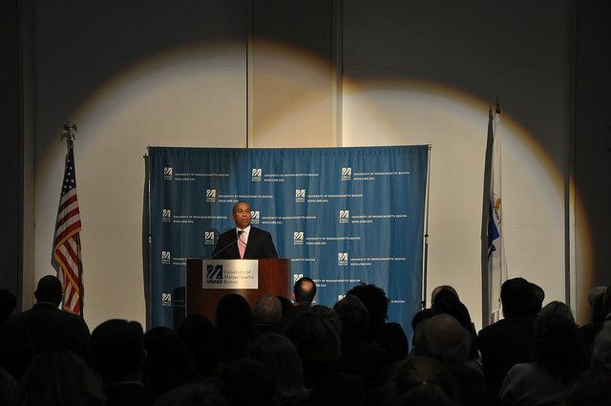

Governor Patrick outlines bold new strategies aimed at closing the most persistent achievement gaps among Massachusetts students, Wednesday, November 9, 2011. (Photo: Matt Bennett/Governor's Office)
Click here to watch the video.
Click here to read the speech.
BOSTON – Wednesday, November 9, 2011 – Governor Deval Patrick today announced several new strategies aimed at closing the most persistent achievement gaps among Massachusetts students during the Patrick-Murray Administration’s Education Summit at University of Massachusetts, Boston. The Governor outlined significant progress made in closing achievement gaps since the Achievement Gap Act was signed in 2010, and laid out key initiatives that the Administration will pilot in the Commonwealth’s Gateway Cities to ensure that all students are prepared for success in the classroom and beyond.
“The Commonwealth’s record of student achievement is second to none and a model for the nation,” said Governor Patrick. “I am proud of the progress we have made, but we won’t be satisfied until we have a system that prepares all of our students for success.”
“With this renewed education strategy, we will build upon the state’s academic success by focusing more resources within Gateway Cities,” said Lieutenant Governor Timothy Murray. “In doing so, we will help Massachusetts move towards our goal of closing the achievement gap among students and preparing students for the future workforce while also driving regional economies across the state.”
The Governor’s second term education strategy will focus on four goals: (1) getting every child to reading proficiency by the third grade; (2) providing every child with a healthy platform for education; (3) creating a differentiated education system that meets each student, particularly English Language Learners, where they are; and (4) preparing all students for college and career success. Governor Patrick’s plan also calls for the creation of a statewide Commonwealth Education Innovation Fund, a public-private fund-raising partnership that will strengthen our capacity to meet 21st Century education challenges. This fund will not be limited to the Gateway Cities.
Each of these goals align with the Administration’s efforts to ensure that every child, regardless of socioeconomic background, is prepared for success. These initiatives will focus on closing achievement gaps in Gateway Cities, where they are most persistent. The Commonwealth’s Gateway Cities are home to many of the state’s immigrants, low-income students, English Language Learners and others stuck in the achievement gaps. The challenges faced by students, their families and their educators in the Gateway Cities are pressing, and the Governor’s plan provides an intense focus achievement gaps where they are most persistent, to help overcome those challenges.
Every child must read proficiently by the third grade. Three-quarters of children who struggle with reading in third grade will continue to struggle academically, greatly reducing their chances of graduating high school, going to college or successfully participating in our high skill economy. To meet the Governor’s goal of reading proficiency by grade 3, the Administration will create a Kindergarten Readiness Literacy Pilot Program in Gateway City Districts. The program will be designed to support at-risk students with an intensive summer program between pre-k and kindergarten and will place special emphasis on early literacy development.
Every child is entitled to a healthy platform for education. In order to benefit from high quality education, students must attend school regularly and be attentive, motivated and ready to learn. The challenges associated with poverty present serious impediments that prevent students from realizing their full academic potential. To combat these challenges, the Administration will create Student Support Councils in all Gateway Cities and provide Student Support Counselors to predominantly low-income schools in Gateway Cities. Support Councils will consist of local human and social service providers focusing their efforts on connecting with students and families in each city’s predominantly low-income schools. Support Counselors will work to connect families and students with service providers who can help them mitigate the problems that impede school attendance and effort.
Students need an education system that meets them where they are. Every student should receive the quantity and quality of instruction they need to meet high proficiency standards. In order to better provide students, specifically students for whom English is a second language, with the opportunities, challenge and support needed to be successful, the Administration will pilot Gateway Cities Summer English Learning Program designed to give English Language Learners (ELLs) more time to acquire competence in English. This program will improve learning and close achievement gaps for ELLs while establishing the necessity of differentiating between our students and giving those who need it sufficient time to learn English.
Students must be prepared for both college and career success. A successful education system is one that prepares all students for lifelong success. This means establishing multiple pathways through secondary school and college education by exposing our students, early in high school, to career options, giving each student access to quality internships, assessing career readiness and more tightly linking secondary school achievement with college admission. To this end, the Administration will pilot high school career academies in several Gateway Cities to offer high school students the opportunity for early career exploration, more applied learning, and motivating educational experiences.
“This set of strategies will continue our efforts to close persistent achievement gaps among our neediest children, while challenging all of our students to do significantly better, meeting the challenge for success in our global economy,” said Education Secretary Paul Reville.
Massachusetts continues to be a national leader in student achievement and education reform efforts. In Early Education and Care, the Department recently launched the Quality Rating and Improvement System, a framework of high standards designed to elevate the quality of care for pre-K children. In higher education, the Administration has set a course for national leadership in post-secondary education through the Vision Project, recognizing that the Commonwealth needs the best educated citizenry and workforce in the nation and it is the job of public higher education to achieve that result.
The Achievement Gap Act, signed by Governor Patrick in 2010, ushered in the most significant set of changes in education since the landmark 1993 Act. With new focus, rules, tools and supports provided by the Achievement Gap Act, two-thirds of the state’s chronically underperforming schools have already shown significant improvements on the latest MCAS exams. Last year, a record number of charter schools, operated by the best providers in the Commonwealth, opened new schools in districts with the greatest need, providing services to students caught in achievement gaps. Additionally, 18 Innovation Schools are now open in communities across the Commonwealth, and another eight are well underway in the planning process. The Achievement Gap Act is providing educators with the tools and flexibilities they need to prepare all students for success, and the new strategies outlined by the Governor today will ensure that all means all.

