United States Department of the Interior
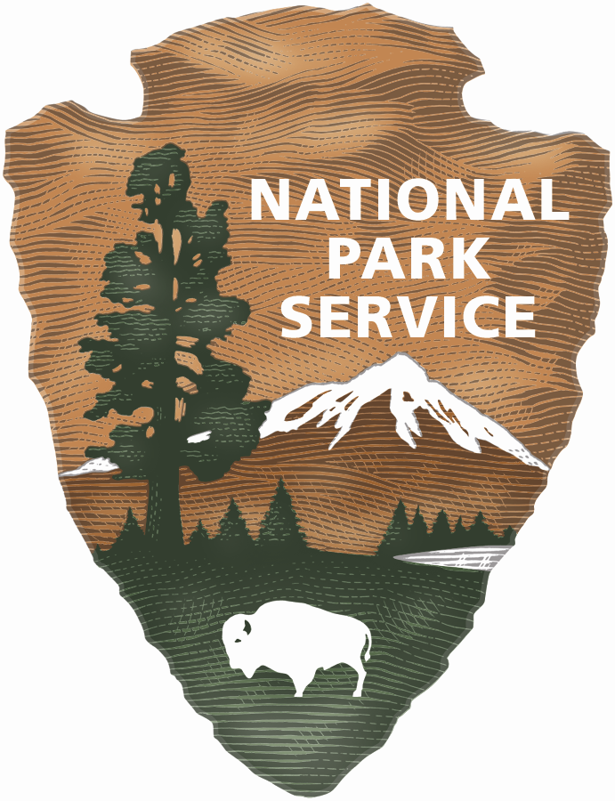
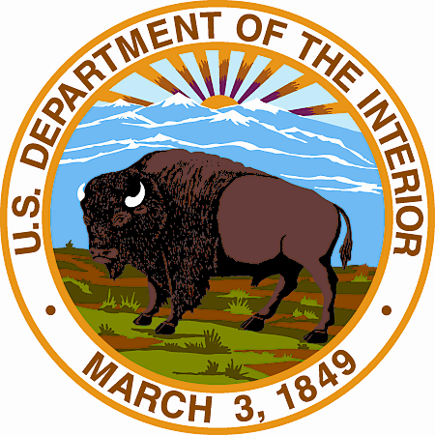

NATIONAL PARK SERVICE
Vicksburg National Military Park
3201 Clay Street
Vicksburg, Mississippi 39183-3495

January 11, 2012

Governor Deval Patrick
Massachusetts State House
Office of the Governor
Room 280
Boston, MA 02133

Dear Governor Patrick,

This is a request for a proclamation from the Commonwealth of Massachusetts to Vicksburg National Military Park honoring Civil War Massachusetts Soldiers that were involved in the 1863 Vicksburg Campaign.

Congress established the Vicksburg National Military Park in 1899 to commemorate the campaign, siege, and defense of Vicksburg, and to preserve the history of the battles and operations of the siege and defense on the ground where they were fought. In 1990 Congress expanded the park’s interpretive mandate to interpret the campaign and siege of Vicksburg from April 1862 to July 4, 1863, and the history of Vicksburg under Union occupation during the Civil War and Reconstruction. This year marks the 150th anniversary of the Vicksburg Campaign.

The Massachusetts Memorial was the first state memorial to be erected in Vicksburg National Military Park and was dedicated on November 14, 1903. The Memorial honors the 29th, 35th, and 36th Massachusetts Infantry Regiments that arrived in June, 1863.

May 15, 2013, has been designated Massachusetts Day at Vicksburg National Military Park. Park staff will lay a wreath at the Memorial honoring the sacrifices of Massachusetts Soldiers. I am requesting that you issue a proclamation for that day. The proclamation will be read at the Memorial during the wreath laying ceremony.

I have attached a proposal for your use. Chief of Operations Rick Martin is the point of contact and can be reached by phone at (601) 619-2905, or email at rick_martin@nps.gov.

Thank you for your consideration of this request.

Respectfully,

R. Michael Madell
Superintendent

