GOVERNOR PATRICK SIGNS ANTI-HUMAN TRAFFICKING LEGISLATION

Drastically increases punishment for offenders, protection for victims
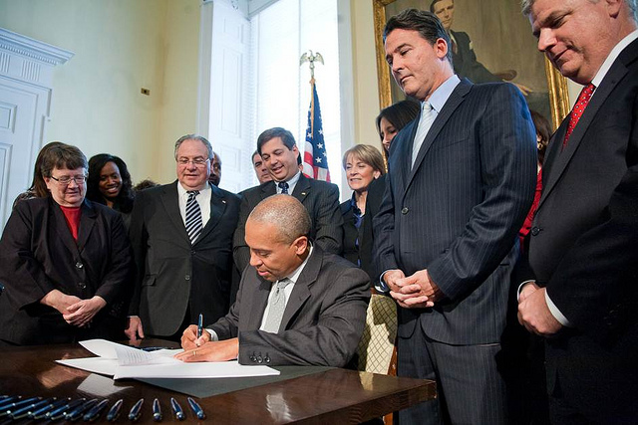

Governor Patrick joins Attorney General Martha Coakley, House Speaker Robert DeLeo, Suffolk County District Attorney Daniel Conley and others at the bill signing. (Photo: Eric Haynes/Governor’s Office)
BOSTON – Monday, November 21, 2011 – Governor Deval Patrick today signed into law H. 3808, “An Act Relative to the Commercial Exploitation of People,” which strengthens protections for victims of human trafficking and prostitution and increases the punishment for offenders by carrying a potential life sentence for traffickers of children.
“I thank the legislature and the Attorney General for making this critical legislation a priority this session,” said Governor Patrick. “I am proud to sign into law this bill that will protect innocent victims and give Massachusetts the tools to prosecute the criminals committing these egregious crimes to the fullest extent.
“Human trafficking is a real issue, impacting innocent children, women and men across the Commonwealth,” said Lieutenant Governor Timothy Murray, Chair of the Governor’s Council to Address Sexual and Domestic Violence. “We thank the state legislature, Attorney General Coakley, advocates and other stakeholders who made their voices heard on behalf of victims exploited by these horrific acts.”
With the Governor’s signature, the legislation establishes the state crime of human trafficking for sexual servitude. Defined as intentionally subjecting, enticing, harboring, transporting or delivering another with the intent that the person engage in sexually explicit performance, production of pornography or sexual conduct for a fee or benefiting from sexual conduct of another, human trafficking for sexual servitude is now punishable by a mandatory-minimum term of five years, with a potential maximum sentence of up to 20 years, and a fine of up to $25,000. Human trafficking for sexual servitude involving a victim under 18 carries a potential maximum sentence of life in prison. A business entity convicted of human trafficking for sexual servitude may be fined up to $1 million.
“Today, we take a major step toward ending the exploitation of children and other victims in our Commonwealth," said Attorney General Coakley. "As it should now be clear, these crimes aren’t only occurring in other countries and other states, but right in our own communities. I want to thank Governor Patrick for signing this bill into law to give us the tools to combat these egregious crimes while offering critical services to victims. I would also like to thank Senator Montigny and Chairman O’Flaherty for sponsoring this bill. Finally, I want to thank the many survivors of human trafficking who shared their personal stories to help other victims---their voices helped this new law become a reality.”
In response to the growing use of the internet as a human trafficking tool, the legislation will establish enticing a child to engage in prostitution, human trafficking or commercial sexual activity by electronic communication a crime, punishable by up to five years in state prison or a fine of $2,500 or both. A second or subsequent offense is subject to a mandatory five-year sentence and a fine of not less than $10,000.
The legislation requires the Department of Children and Families (DCF) to provide comprehensive services to all victims of child sexual exploitation, including state-funded social and legal services.
“This legislation gives the Commonwealth vital tools to assist victims of trafficking,” said Secretary of Health and Human Services Dr. JudyAnn Bigby. “With the Governor’s signature today, the Department of Children and Families will provide comprehensive services that will protect and support people who are sexually exploited, including children.”
The legislation requires DCF to provide an advocate who would accompany a sexually exploited child to all court appearances. The bill allows the DCF Commissioner, subject to appropriation, to contract with non-governmental organizations with experience working with sexually exploited children to provide training to law enforcement, in order to assist the police and prosecutors in interacting with and obtaining services for sexually exploited children.
“With this bill, the Commonwealth is taking another important step in ensuring the safety of our children,” said DCF Commissioner McClain. “It is incumbent upon all of us to protect and care for these victims of exploitation. The Department of Children and Families is proud to offer comprehensive services, support, and advocacy for these children and youth.”
The legislation also amends the definition of a "Child in Need of Services" to include a sexually exploited child, and it allows for the "safe harbor" of sexually exploited children from prosecution for certain sex crimes. The court with jurisdiction over the case can require the child to comply with services in exchange for non-prosecution.
“If you’re going to engage in the unthinkable exploitation of children and other people, you’re going to pay the price,” said Senate President Therese Murray. “This legislation lays out serious punishments to help prevent human trafficking. It is the result of a lot of good work from human rights advocates, the legislature, especially Senator Montigny who has put in so much time and effort, and the attorney general. Massachusetts was one of only a few states without such a law, and I’m glad we got it done.”
The legislation will create a Victims of Human Trafficking Trust fund, funded from assets seized and forfeited from the crimes established under the bill, and allows DCF to apply to the victim and witness assistance board for grants from the Trust Fund to provide services to the victims.
“As legislators, it is a priority to ensure the safety of people across the Commonwealth – especially those who are most vulnerable,” said House Speaker Robert A. DeLeo. “No one should have to experience the utter horror of being sold into a life of exploitation; it is simply unjust. This anti-human trafficking legislation will sharpen law enforcement’s ability to take action on instances of this despicable practice in Massachusetts.”
The legislation also targets the new crime of organ trafficking. Recruiting, enticing, harboring, transporting, delivering or obtaining by any means another person with the intent to have an organ or body part removed for sale or benefiting from organ trafficking – is punishable by up to 15 years in state prison or a fine of $50,000 or both. Organ trafficking involving a child under 18 is punishable by a mandatory sentence of five years.
“This is the most important piece of legislation I have passed since joining the Senate,” said Senator Mark Montigny, author of the legislation. “I filed the original bill six years ago. During this time I have continually fought for a bill that would protect victims and survivors of this horrific crime. While the wait has been frustrating, at least we can say to those who have been wronged that a great bill has finally been passed, which is going to make a difference. We cannot repair the spirits that have been broken, but we can provide services for those victims that need help recovering, and prosecute the traffickers to the fullest extent of the law.”
“Passing this bill into law will move our Commonwealth to the forefront of the fight against the horrors of human trafficking," said Senator Bruce Tarr. "Now we will have modern and effective tools to confront the people who profit from enslaving others.”
Finally, the legislation will create an interagency task force, chaired by the Attorney General, to address all aspects of human trafficking, including sex and labor trafficking. The 19-member interagency task force will address all aspects of human trafficking. The task force includes the Secretary of Public Safety and the Colonel of the State Police, two police and one district attorney representative, representatives from several other state agencies, and eight gubernatorial appointees representing various areas of expertise or interest groups.
"It is so sad that many people don't even realize this is happening right here in Massachusetts," said Senator Jennifer L. Flanagan. "I was very proud to have served on this vitally important conference committee. We are sending a very stern message with this legislation that this type of activity will not be tolerated. Again, I am so proud of the Legislature for acting on this bill and for sending it to the Governor."
“Human trafficking is an insidious offense, and this new law will provide law enforcement with the tools they need to prosecute those who engage in and profit from it,” said Senator Cynthia Creem. “I am also very pleased that the law will offer ‘safe harbor’ and social services to child-prostitutes, recognizing that they are victims – not criminals.”
“I am so thrilled this urgent and important piece of legislation has been signed into law,” said Representative Sheila Harrington. “As a conference committee, we worked hard so that this bill would ensure the protection of the people of the commonwealth against these criminals.”
“I hope that this legislation will help us put a stop to the horrendous industry of human trafficking, and that it will provide pathways to a better life for those of our youth that have been compelled and lured into being commercially sexually exploited," said Representative Liz Malia.
“Massachusetts now has the most comprehensive human trafficking laws in the country,” said Representative Eugene L. O’Flaherty. “This bill gives law enforcement and prosecutors the tools they need to combat this issue that is often hidden from society and provides victims, particularly young children, with the safety and services they need to get their lives in order. The Legislature has no sympathy for those who prey upon others and these individuals will face harsh penalties and sex offender registration requirements.”

