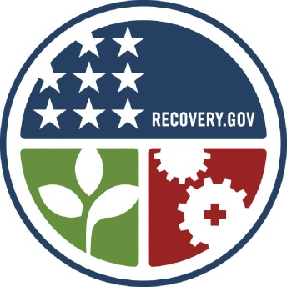
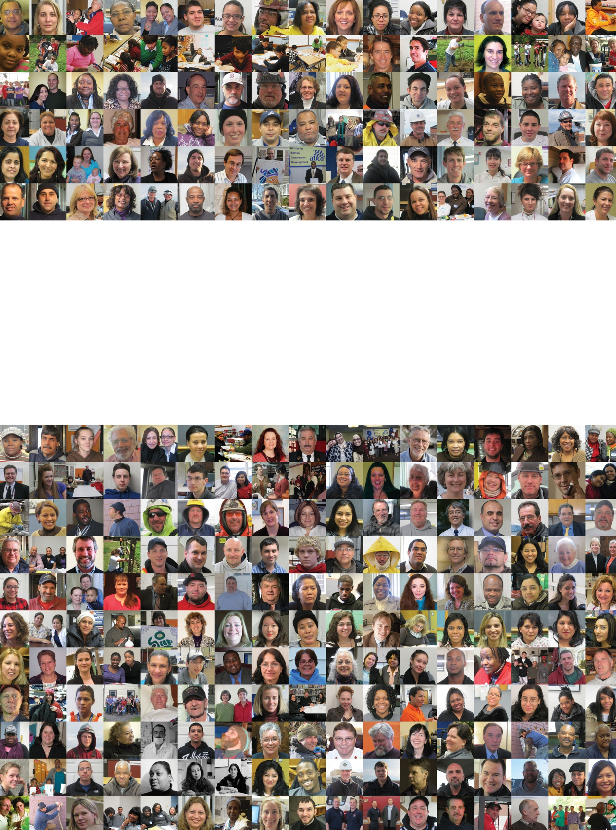
Citizens’ Update XVIII

Eighteenth Reporting Period Highlights

October 1 – December 31, 2013
Massachusetts Recovery and Reinvestment Office
(617) 979-8380 | Contact.Stimulus@massmail.state.ma.us
www.mass.gov/recovery
Recovery Act Impact on Massachusetts
As of December 31, 2013
- $7.50 billion in awards to state agencies
- 98% - $7.36 billion of awards committed by state agencies
- 97% - $7.29 billion of awards spent by state agencies and there are 561 fully completed projects and programs
  - $4.34 billion spent on direct benefits (Unemployment Insurance, Supplemental Nutrition Assistance Program, Medicaid, and other Safety Net Programs)
  - $2.95 billion spent on programs and infrastructure projects through state agencies
- 857 full-time equivalent (FTE) jobs funded by ARRA reported to the federal government between October 1 and December 31, 2013 with an additional 4 FTEs not subject to federal reporting, for a total of 862 FTEs for the quarter
- 3,129 actual individual workers reflected in this quarter’s funded FTE count
- 1,565 estimated indirect jobs created or retained
- 4,694 estimated total employment impact (3,129 direct and 1,565 indirect)
- 103,529 individuals received an ARRA-funded paycheck between February 17, 2009 and
December 31, 2013.

Stimulus Works – Program and Project Highlights

This will be the final Citizens’ Update published by the Massachusetts Recovery and Reinvestment Office. The Federal Fiscal Omnibus Spending Bill for 2014 included a repeal of the 1512 quarterly ARRA recipient reporting. The Federal Recovery Accountability and Transparency Board (RATB) recently announced that Q4 2013 will be the final 1512 quarterly reporting period. It is working in collaboration with the Office of Management and Budget to develop a process for recipients and agencies to review reports and make final corrections after February 1, 2014.

Over the past quarter most of the recovery projects have been completed. As of December 31, 2013, 392 of 400 awards have over 561 projects and programs that have been fully completed. For more information on individual projects and programs, and to see stories from the past four years of economic recovery in Massachusetts, please visit www.mass.gov/recovery
The Whole Picture – Where your Recovery Dollars are Going
(Cumulative through December 31, 2013)
Note: This table shows a summary of all Recovery Dollars Massachusetts has collected from state agencies. Information reported to the federal government is shaded in light green. All numbers are rounded to the nearest thousand dollars. For more detailed project and program information, please visit www.mass.gov/recovery.
Funding Category | Awarded to |  | Total Committed |  | Expended
Funding Category | State Agencies
Awards Subject to 1512 Reporting to the Federal Government
Education |  | 2,015,434,000 |  | 1,970,160,000 |  | 1,900,005,000
Clean Energy & Environment |  | 237,419,000 |  | 234,965,000 |  | 233,680,000
Housing |  | 115,590,000 |  | 115,025,000 |  | 115,025,000
Workforce Programs |  | 77,349,000 |  | 77,224,000 |  | 77,224,000
Public Safety & Homeland Security |  | 42,635,000 |  | 41,420,000 |  | 41,420,000
Transportation |  | 396,920,000 |  | 368,279,000 |  | 367,018,000
Safety Net Programs |  | 22,678,000 |  | 22,554,000 |  | 22,554,000
Technology & Research |  | 89,231,000 |  | 89,316,000 |  | 88,356,000
Subtotal |  | 2,997,256,000 |  | 2,918,942,000 |  | 2,845,283,000
Awards Not Subject to 1512 Reporting to the Federal Government
Accountability |  | 14,796,000 |  | 13,728,000 |  | 13,211,000
Clean Energy & Environment |  | 7,196,000 |  | 7,196,000 |  | 7,196,000
Housing |  | 110,346,000 |  | 109,101,000 |  | 109,101,000
Safety Net Programs |  | 4,369,720,000 |  | 4,313,314,000 |  | 4,313,314,000
Technology & Research |  | 193,000 |  | 191,000 |  | 191,000
Subtotal |  | 4,502,251,000 |  | 4,443,530,000 |  | 4,443,014,000
Grand Total |  | 7,499,507,000 |  | 7,362,472,000 |  | 7,288,296,000

The Whole Picture – January 2014 Reporting Period Jobs Impact
(October 1 through December 31, 2013)
Note: This table shows a summary of Recovery Act jobs Massachusetts has collected through state agencies during the most recent reporting cycle. Information reported to the federal government is shaded in light green. FTEs are rounded to the nearest whole number. For more detailed project and program information, please visit www.mass.gov/recovery.
Funding Category | Direct Full Time Equivalent Count (FTEs) | Actual Worker Count
Awards Subject to 1512 Reporting to the Federal Government
Education | 836 | 3,057
Clean Energy & Environment | 20 | 45
Housing | 0 | 0
Workforce Programs | 0 | 0
Public Safety & Homeland Security | 0 | 0
Transportation | 0 | 6
Safety Net Programs | 0 | 1
Technology & Research | 1 | 13
Subtotal | 857 | 3,122
Awards Not Subject to 1512 Reporting to the Federal Government
Accountability | 4 | 7
Clean Energy & Environment | 0 | 0
Housing | 0 | 0
Safety Net Programs | 0 | 0
Technology & Research | 0 | 0
Subtotal | 4 | 7
Grand Total | 862 | 3,129

Detail on ARRA FTEs and Headcounts – January 2014 Report
Note: All FTE values are rounded to the nearest whole number. For more detailed project and program information, please visit www.mass.gov/recovery.
Awards Subject to 1512 Reporting to Federal Government
Secretariat | Direct Full-Time Equivalent Count (FTEs) |  |  |  |  | Actual Worker Count
Secretariat | Total | Created | Retained | Govt. | Non-Govt. | Total | Created | Retained
Attorney General | 0 | 0 | 0 | 0 | 0 | 0 | 0 | 0
District Attorneys | 0 | 0 | 0 | 0 | 0 | 0 | 0 | 0
Education | 836 | 207 | 630 | 813 | 24 | 3,057 | 540 | 2,517
Housing & Economic Development | 0 | 0 | 0 | 0 | 0 | 0 | 0 | 0
Health & Human Services | 0 | 0 | 0 | 0 | 0 | 1 | 1 | 0
Labor & Workforce Development | 0 | 0 | 0 | 0 | 0 | 0 | 0 | 0
Energy and Environment | 0 | 0 | 0 | 0 | 0 | 0 | 0 | 0
Public Safety & Security | 0 | 0 | 0 | 0 | 0 | 0 | 0 | 0
Transportation | 0 | 0 | 0 | 0 | 0 | 6 | 5 | 1
University of Massachusetts | 21 | 0 | 21 | 18 | 3 | 58 | 0 | 58
Subtotal | 857 | 207 | 651 | 831 | 27 | 3,122 | 546 | 2,576

Awards Not Subject to 1512 Reporting to Federal Government

Secretariat/Department | Direct Full-Time Equivalent Count (FTEs) |  |  |  |  | Actual Worker Count
Secretariat/Department | Total | Created | Retained | Govt. | Non-Govt. | Total | Created | Retained
Administration & Finance | 4 | 2 | 2 | 4 | 1 | 7 | 5 | 2
Energy and Environment | 0 | 0 | 0 | 0 | 0 | 0 | 0 | 0
Subtotal | 4 | 2 | 2 | 4 | 1 | 7 | 5 | 2
Grand Total | 862 | 209 | 653 | 834 | 28 | 3,129 | 551 | 2,578

Beneficiaries
This narrative provides the details of various ARRA program awards that are having a real impact on our citizens every day – over and above the jobs that have been created by Recovery dollars. While many of these initiatives are ones that have existed for several years, the injection of ARRA funds has allowed for the continuation and even expansion of these programs during these hard economic times. The beneficiaries listed below represent citizens across the Commonwealth from neighborhoods in every city and town. The numbers shown are an estimate by each state agency of the beneficiaries impacted so far because of the additional ARRA funds going into these programs. For more detailed project and program information, please visit www.mass.gov/recovery

Administration and Finance
Program Highlights | Beneficiaries
Impact on Child Support Incentives (Federal Match) Program run by the Child Support Enforcement Division, within the Department of Revenue, currently services in excess of 200,000 child-support cases. (Completed June 2011). | Over 200,000

Health and Human Services
Program Highlights | Beneficiaries
Congregate Meals Grant helps provide fresh meals on a statewide basis through a network of 23 community based local Area Agencies on Aging (AAAs), which provide a wide range of services to elders and their families.  (Completed December 2010). | 13,969
Medicaid Federal Medical Assistance Percentage (FMAP) allows Massachusetts to avoid what would have been even deeper cuts throughout state government. A large portion of these dollars went toward the maintenance of the MassHealth program to preserve critical medical services to over 1.2 million recipients. (Completed October 2011). | Over 1,200,000
Home Delivered Nutrition Services helps elders with nutritional needs to become or remain healthy, independent, and active in their communities. (Completed December 2010). | 4,228
Vocational Rehabilitation Services – ARRA funds are used by the Massachusetts Rehabilitation Commission to support a number of projects designed to assist individuals with disabilities. (Completed December 2011). | 3,037
Supplemental Assistance Nutrition Program handled an unprecedented 30% increase in enrollment in the Supplemental Nutrition Assistance Program (SNAP, formerly known as Food Stamps). Beginning in April 2009, benefit amounts rose by 18% due to federal stimulus funding (resulting in a sizable monthly increase for most families). (Completed December 2010). | 770,000
Infants and Families with Disabilities (IDEA) benefits infants and toddlers through age 3 who have or are at risk for developmental delays.  (Completed September 2010). | 8,082

Housing
Program Highlights | Beneficiaries
Community Development Block Grant for infrastructure improvements and public housing modernization awarded to provide services to the most vulnerable in our communities, and to create jobs through the expansion and retention of businesses. (Completed September 2012) | 2,375
Tax Credit Assistance Program supports Low Income Housing Tax Credit Projects that were stalled due to unfavorable financial market conditions. (Completed February 2012) | 2,493
Community Services Block Grants provided assistance to local communities, working through a network of 24 Action Agencies to reduce poverty, revitalize  low income communities, and empower low income families and individuals to become fully self-sufficient. (Completed in September 2010) | 63,812
Weatherization Assistance Program aims to increase the energy efficiency  of dwellings occupied by low income persons, reduce their total home energy expenses, and improve their overall health and safety. The program targets particularly vulnerable people such as the elderly, the disabled and low-income families with children. (Completed September 2012) | 48,724
Homelessness Prevention and Rapid Re-Housing Program provides services to individuals or families who are homeless or in danger of becoming homeless, including re-housing assistance, eviction prevention services, and subsidies to help families and individuals move out of shelters and motels.  (Completed July 2012) | 8,053

Labor and Workforce Development
Program Highlights | Beneficiaries
Federal Additional Unemployment Compensation has allowed over 660,000 individuals from across the Commonwealth to receive an additional $25 per  week benefit compensation as a result of the Recovery Act.  (Completed December 2010). | 663,773
WIA Recovery Act Title 1 Services for Adult, Dislocated and Youth Workers funds directly benefit low-income individuals of the Commonwealth who qualify under the Workforce Investment Act (WIA) and received employment and training services. Qualified youth received employment opportunities.  (Completed September 2011). | 19,250
Wagner-Peyser Act Employment Services benefits employed and unemployed workers seeking to upgrade their skills and obtain jobs, and provides customized services to clients with special needs, including veterans, individuals with disabilities, and unemployment claimants likely to exhaust their benefits. (Completed September 2011). | 161,202

Public Safety
Program Highlights | Beneficiaries
State Fiscal Stabilization Fund – Government Services funds were expended to support Massachusetts municipal fire departments impacted by budget cuts that have forced layoffs and also vacancies resulting from attrition. Awards through this program have allowed the Commonwealth to retain 263 firefighters in 85 municipalities. (Completed December 2011). |  | 263 firefighters, benefiting residents of 85 cities & towns
Byrne Justice Assistance Grant (JAG) funds are supporting municipal police staffs, employment initiatives and jobs for youth, and maintaining vital services in state public safety agencies. In each of these initiatives, the focus has been on preserving or creating jobs crucial to sustaining and enhancing public safety. More than $6 million in JAG funds have been awarded to 35 cities and towns to support police departments’ re-hiring laid off officers, hiring of new officers, and supporting overtime and other personnel costs.  (Completed June 2013) |  | 2,505 Statewide
The Violence Against Women Act (VAWA) STOP Grants enhance services and advocacy to victims, improve the criminal justice system's response and promote effective law enforcement, prosecution, and judicial strategies to address domestic violence, dating violence, sexual assault, and stalking. (Completed December 2011). |  | 17,055 victims who received assistance

Education
Program Description | Beneficiaries
Race to the Top – Massachusetts received the top score on its application for funds from the US Department of Education’s Race to the Top competition.  The initiatives in Massachusetts’ application were driven by the core belief that the persistent variation in student outcomes stems from both discrepancies in the quality of curriculum and instruction, and unrelated out-of-school circumstances that can affect a student's ability to learn. Each element in our proposal is designed to reduce this variation by focusing on improving the quality of teaching and learning each student receives and on providing students and families with the health and human service supports they require.  Overall, we aim to achieve four objectives:  1. Attract, develop, and retain an effective, academically capable, diverse, and culturally competent educator workforce to ensure every student is taught by a great teacher and every school and district is led by a great leader  2. Provide curricular and instructional resources to provide every educator with the tools necessary to promote and support student achievement  3. Concentrate great instruction and supports for educators, students, and families in our lowest performing schools to create the conditions needed for improved student achievement  4. Increase dramatically the number of students who graduate from high school ready for college and career  These objectives have garnered widespread support: 276 school districts signed on to Massachusetts' Race to the Top proposal (70 percent of the 393 districts eligible to sign). These school districts represent 1,375 schools, 74 percent of K-12 public school enrollment, and 88 percent of students in poverty. | Students and educators in 276 school districts
Education Jobs Fund – This grant provided an extra $204 million in aid to provide assistance to states to save or create education jobs for the 2010-2011 school year. (Completed December 2012) | Students and educators in  327 districts
School Improvement Grants aim to strengthen State capacity to provide leadership in implementing effective school improvement strategies for local educational agencies (LEAs) and schools that have been identified for improvement, are in corrective action, and are in the restructuring process and (2) providing resources to LEAs to support school improvement activities, including the development and implementation of effective restructuring plans. | 12 schools that have been awarded “turnaround grants”
State Fiscal Stabilization Fund – Education Stabilization Fund monies were expended to maintain the fiscal stability of the K-12 and public higher education systems and provide continued support to teachers, administrators, and staff members in school districts and also at our community colleges, state universities, and the University of Massachusetts campuses. In addition, funds were spent (in accordance with guidance issued by the U.S. Department of Education) to address infrastructure needs at these institutions. Most importantly, these funds were expended to maintain and enhance students' access to high-quality educational opportunities in K-12 schools and at our public institutions of higher education. (Completed December 2011). | Students and educators at all levels statewide – K-12, state universities and community colleges and the University of Massachusetts
Title I, Part A funding improves teaching and learning for students most at risk of failing to meet State academic achievement standards. Grants were awarded to 258 districts that serve 202,166 students who are directly eligible to receive Title I services. Massachusetts has received an additional $163 million in two types of Title I funding to supplement the $243 million that the state received in 2009, an increase of 67 percent. (Completed December 2012) | Students and educators in  258 districts
Individuals with Disabilities in Education Act (IDEA), Part B Pre-School Grants were awarded to 179 districts that serve 9,000 children who are eligible to receive special education services. (Completed January 2012) | Students and educators in 179 school districts
Individuals with Disabilities in Education Act (IDEA), Part B Grants to States support the provision of special education services to children with disabilities. Grants were awarded to 389 districts that serve approximately 165,000 students who are eligible to receive special education services. (Completed December 2011). | Students and educators in  389 districts
Child Care Development Fund (CCDF) assistance benefits youth who received the summer learning vouchers, their parents who retained work as  a result of having these vouchers, and the staff members who were employed because their programs received these vouchers.  (Completed September 2011). | 47,635
USDA Child Nutrition Recovery Act serves 114 schools in 31 districts, serving a total enrollment of approximately 60,000 students. These funds were used to purchase new food service equipment for the schools.  (Completed December 2010). | Students and educators in  31 districts
USDA Child Nutrition Programs – Elementary and Secondary Education grants were awarded to four local community food banks that serve approximately 750 local food pantries and soup kitchens throughout the state. (Completed March 2011). | 4 community food banks, serving 750 food pantries
Transportation
Program Description | Beneficiaries
ARRA transportation projects are improving the roadways, transit systems, and pedestrian/bike and ferry facilities, throughout each of the Commonwealth's 14 counties. The highway projects include 95 roadway and bridge improvement projects. Improving the transportation system of the Commonwealth impacts the daily life of our citizens as well as providing the essential infrastructure for commerce. 99 transportation projects have been completed as of December 31, 2013. | Community-wide

Energy and Environment
Program Description | Beneficiaries
USFS Native Species Ecological Restoration Grant benefits residents of Worcester and Berkshire counties in Massachusetts by detecting and eradicating the destructive Asian Long-horned Beetle and other invasive insect species that destroy trees and other vegetation. (Completed December 2011). | Residents of Worcester and Berkshire counties
State Energy Program aims to provide leadership to maximize the benefits of energy efficiency and renewable energy in Massachusetts. The Department of Energy Resources is working to substantially increase solar energy resources  in state facilities, as well as to reduce energy waste and increase renewable energy projects across the Commonwealth. This program includes $8 million in rebates for over 100 private solar projects. (Completed November 2012) | Community-wide
Energy Efficiency and Conservation Block Grants will advance clean energy technology and energy efficiency goals at the community level. This will include both funding to assist with energy efficiency projects and to provide technical assistance to municipalities. (Completed October 2012) | Community-wide
The Leaking Underground Storage Tank program will provide Massachusetts with funds for the remediation of known storage tanks buried underground that are or have been compromised and are leaking petroleum into the environment. Leaking tanks pose threats to drinking water and surface water in the immediate area of the tank as well as to the larger surrounding environment as pollution spreads. Communities affected by this grant include Dorchester, Grafton, Holyoke, Lawrence, Malden, Mattapan, Middlefield, Rehoboth, Shutesbury and Wrentham. (Complete October 2012) | Community-wide

For more detailed project and program information, please visit Completed ARRA projects in Massachusetts
Totals may not add due to rounding. For exact figures, please visit www.mass.gov/recovery.
Using a multiplier of 1.5
Totals may not add due to rounding. For exact figures, please visit www.mass.gov/recovery.
Totals may not add due to rounding. For exact figures, please visit www.mass.gov/recovery.
Totals may not add due to rounding. For exact figures, please visit www.mass.gov/recovery.

