GOVERNOR PATRICK LEADS MASSACHUSETTS-ISRAELI FORUM ON GROWING CLEAN ENERGY AND GREEN JOBS SECTORS
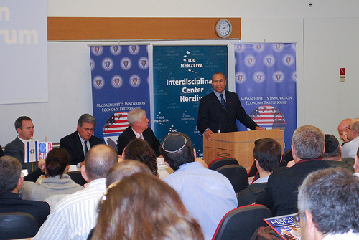

Governor Patrick speaks at a clean tech forum at the Interdisciplinary Center in Herzliya. (Photo credit: Alex Goldstein/Governor's Office). View additional photos.
HERZLIYA - Tuesday, March 8, 2011 - As part of the Massachusetts Innovation Economy Partnership Mission 2011, Governor Deval Patrick today led a forum on growing the clean energy and green jobs sectors in Massachusetts and Israel at the Interdisciplinary Center in Herzliya. The forum is part of the Governor's mission to explore growth opportunities in clean tech economy between the state's established and emerging partners in Israel.
"Like Israel, Massachusetts is proud to be a global leader in the clean energy and green jobs economy," said Governor Patrick. "With our talented people, world-class institutions, and supportive government leaders we are letting the world know that Massachusetts is a great place to start or grow a clean energy business."
Governor Patrick brought together leaders in the Massachusetts and Israeli clean-tech sectors at the Interdisciplinary Center - Israel's first private college - to discuss his vision for expanding collaboration and job opportunities within the industry. Earlier in the day, the Governor's clean tech delegation from Massachusetts toured Pythagoras Solar in Petach Tikva, and met with leaders from the venture capital firm Israel Cleantech Ventures.
"Governor Patrick's leadership, bolstered by the pacesetting policy initiatives enacted since 2007, make Massachusetts fertile ground for a thriving clean energy industry," said Energy and Environmental Affairs Secretary Richard K. Sullivan Jr. "Some 1,500 clean energy companies are already doing business in the Commonwealth, and clean energy sector employment has risen 65 percent in the last four years. With targeted industry support by the Massachusetts Clean Energy Center, we are better positioned than any other state in the country to continue to capitalize on the good jobs, long-term economic growth, and cleaner environment that come from growing a vibrant clean energy sector."
"By bringing together delegations of business leaders and policy makers from regions with pioneering people, policies and academic institutions we are forging a partnership that will further drive innovation in the clean energy industry," said Massachusetts Clean Energy Center (MassCEC) Executive Director Patrick Cloney. "We are eager to collaborate with the Israeli clean tech community to help clean energy companies achieve success faster."
"This delegation offers a great opportunity for Israel's vibrant cleantech community to engage with industry leaders and policy makers from a region that is at the forefront of the US cleantech market," said Israel Clean Tech Ventures Partner Meir Ukeles. "Just as earlier generations of Israeli software, communications and life sciences companies built strong ties to Massachusetts, we look forward to energy and water innovation being at the heart of Israel-Massachusetts collaboration going forward."
"Born and bred in Massachusetts, American Superconductor Corporation has emerged as one of the world's leading power technology companies," said Astrid Khokhar, Director of Sales and Marketing for AMSC's Windtec™ brand. "From the U.S. to Europe to the Middle East and Asia, AMSC is helping to make 21st power supplies cleaner, smarter and stronger. We are proud to be joining Gov. Patrick on this trade mission to Israel and the U.K."
Both Israel and Massachusetts are global leaders in developing clean energy technologies and forming clean energy start ups. There are an estimated 1,500 clean energy companies in Massachusetts. Based on a survey of clean energy companies conducted by MassCEC, at least 11,000 people are employed in clean energy sector today, up 65 percent from 2007.
Since the beginning of the Patrick-Murray Administration, Massachusetts has taken an integrated approach in clean energy, creating clean energy jobs, focusing on solar, lighting, biofuels, energy efficiency and security and reducing greenhouse gas emissions. In addition, Massachusetts is soon to be home to Cape Wind, the nations first offshore wind farm.
Today there are nearly 100 companies with Israeli founders or Israeli-licensed technologies in Massachusetts. In 2009, these companies employed nearly 6,000 people and generated $2.4 billion in direct revenue for the state. Local firms exported over $180 million worth of goods to Israel in 2009 and, at 12.35 percent, the United States is Israel's largest source of imports.
The Massachusetts Innovation Economy Partnership Mission 2011 is focusing on business expansion, job growth and collaboration during industry forums, company visits and meetings with Israeli and UK business leaders and government officials in Tel Aviv, Haifa, Jerusalem, London and Cambridge. The Massachusetts delegation arrived in Israel on March 7th, and will depart the United Kingdom on March 17th to return to Boston.

