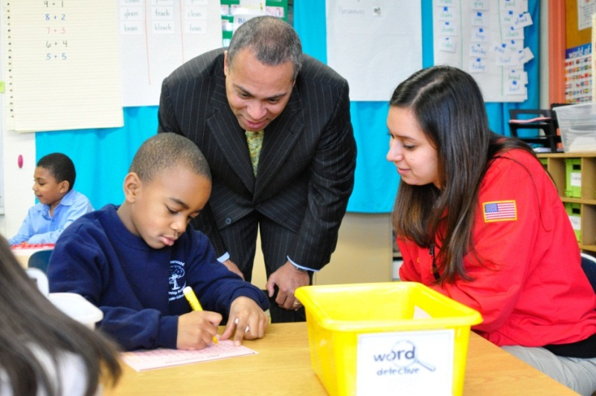

FOCUS ON EDUCATION: CLOSING THE ACHIEVEMENT GAP

Governor Deval Patrick has been a champion of public education in Massachusetts. He proposed and signed the Achievement Gap Act, a sweeping education reform bill that gives educators the tools they need to turn around chronically underperforming schools. The reforms are ensuring a world-class education is within reach for every child, in every neighborhood.
And despite the global economic collapse, Governor Patrick has funded public schools at historically high levels. Today, Massachusetts student performance continues to lead the nation and on some measures, the world – but there is much work left to do.

- CLOSING THE ACHIEVEMENT GAP: The Governor’s second term education strategy focuses on closing achievement gaps, particularly in Gateway Cities. To do this, Massachusetts will work to bring every child to reading proficiency by the third grade; provide every child with a healthy platform for education; meet the needs of English Language Learners; and prepare all students for college and careers.
- PROVIDING INNOVATION IN EDUCATION: The Patrick-Murray Administration is promoting wide adoption of Innovation Schools, the Governor’s signature in-district charter model, to allow schools to tailor their education to unique student needs. New charter schools and turnaround schools are also helping close achievement gaps across the Commonwealth.

- WORLD CLASS HIGHER EDUCATION FOR ALL: The Administration’s historic 10-year Higher Education Bond Bill invests $2.2 billion in state colleges and universities to give all families access to affordable, world class higher education. Lieutenant Governor Timothy Murray is leading an initiative to prepare students and workers for careers in science, technology, engineering, and mathematics (STEM) to compete and win in the global economy.
- #1 RACE TO THE TOP: Massachusetts was awarded $250 million from President Obama’s Administration, after receiving the highest score in the national Race to the Top competition. The Commonwealth is using the resources to provide new tools and resources for radical improvement in our schools.
- LEADING THE NATION IN STUDENT PREFORMANCE: For the fourth time in a row, Massachusetts students finished first in the National Assessment of Education Progress – the “nation’s report card.” Massachusetts students are among the top three in the world on international math assessments and tied for first on the international science and math assessment. On the latest MCAS, two-thirds of turnaround schools made gains of 5% or higher in English and Math proficiency.

