PATRICK-MURRAY ADMINISTRATION HONORS MASSACHUSETTS VETERANS AND FAMILIES

Governor Patrick announces more than $1 million in additional veteran-specific funding
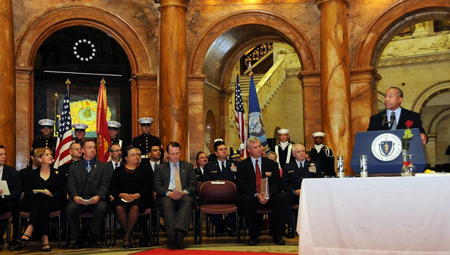

Governor Patrick speaks at the Veterans' Day celebration at the State House on November 11, 2011. (Photo: Holland Hinman/Governor's Office)
BOSTON – Friday, November 11, 2011 – Governor Deval Patrick, Lieutenant Governor Timothy Murray and Department of Veterans Services (DVS) Secretary Coleman Nee today honored Massachusetts service members past and present at the Commonwealth’s annual Veterans’ Day ceremony at the State House. Earlier today, Governor Patrick signed a supplemental budget which includes more than $1 million in funding for Welcome Home Bonus payments and additional veterans benefits.
“Today is a day to express our gratitude, pride and enduring support to the Massachusetts military personnel protecting our interests abroad, and to all of our veterans and their families,” said Governor Patrick. “Here in the Commonwealth, our commitment to our returning servicemen and women has never wavered. To truly honor our heroes, we must focus on expanding access to jobs and services for veterans -- and that’s what we are striving to accomplish every day.”
“As citizens of this Commonwealth and this country, we have an obligation to ensure all veterans have access to the range of services they have rightfully earned,” said Lieutenant Governor Timothy Murray, chair of the Governor’s Advisory Council on Veterans’ Services. “Our Administration is committed to working with municipalities, businesses, educational institutions and other organizations as we continue to build partnerships to enhance and deliver services to the brave men and women who have proudly served our country.”
$700,000 in funding from the Governor's latest supplemental budget will be invested in additional Welcome Home Bonus payments for veterans returning from service abroad, including increasing payments to veterans with multiple tours of duty. $308,000 in funding will be directed to DVS to help coordinate services to veterans and their families and link veterans to federal and state benefits programs.
Last week, the Patrick-Murray Administration announced a comprehensive plan to enhance services for veterans, including re-employment and training of veterans of all eras, especially those returning from the wars in Iraq and Afghanistan. Declaring November as “Hire A Veteran Month”, the Administration is also partnering with a number of trade associations committed to encouraging their member employers to hire veterans for open positions and educate companies of available financial benefits for hiring veterans. Following today’s State House ceremony, Lieutenant Governor Murray and Secretary Nee will join the U.S. Small Business Administration and the International Franchise Association to promote opportunities for veteran-owned small businesses in Massachusetts.
“On Veterans Day, we come together collectively to honor the brave men and women who have served in our armed forces” said Secretary Nee. “We honor the men and women of generations past and those who are currently serving overseas helping our nation stay safe. To all of our veterans, we say thank you for your service.”
Governor Patrick today also presented an award to Smith & Wesson, recognizing the company's long-standing commitment to support re-employment and training opportunities for Massachusetts veterans. By working with the Massachusetts Manufacturing Extension Partnership (MassMEP), Smith & Wesson has hired veterans who have graduated from MassMEP's workforce training program to work at Smith & Wesson’s Springfield-based manufacturing facility.
The program also included a special tribute to women veterans, led by Captain Mary Jo Majors, who has been an officer in the U.S. Navy Nurse Corps for more than 42 years; Captain Majors was Massachusetts’ 2010 Outstanding Woman Veteran of the Year. Tim Sullivan, Commander in the United States Navy (Ret.), a former POW, and Maureen Dunn, of the National League of Families of POW/MIA, led a candle lighting ceremony for those who have been held prisoner or are missing. Gold Star Families were paid tribute with a rose presentation.
"This is the day to remember our country's veterans, past and present, and the service they have given our country," said Secretary of the Commonwealth William F. Galvin. "But beyond this day, we must all work to ensure that the needs of our veterans are met and their sacrifices are never forgotten."
"We celebrate the partnership between the Treasury and the Department of Veterans' Services," said Treasurer Steven Grossman. "The Welcome Home Bonus and our efforts to reunite veterans with their unclaimed property are examples of our profound gratitude toward those who have worked to preserve and protect our freedoms and American values."
“We can and should honor our veterans,” said Auditor Suzanne Bump. “Caring for the wounded and employing our returning veterans are two things to do, but we can also show respect and gratitude by actively participating in the democracy that they have sacrificed to protect. People across the globe are struggling right now to obtain the precious right to elect their own leaders. We honor our veterans by exercising the right which their military service secures for us.”
“On behalf of the Senate, and the Plymouth and Barnstable District, I wish all our veterans and their families the very best,” said Senate President Therese Murray. “Thank you for the sacrifices you’ve made, and for your faithful service to the Commonwealth and the nation. Here in Massachusetts, every day is Veterans’ Day and we will continue to fight for you, as you have fought for us.”
“This Veterans’ Day, the legislature wants to send the message to all of our veterans that we appreciate the bravery that they have shown, the sacrifices made by their families and loved ones, and the positive impact that they’ve made on our nation and its history,” said House Speaker Robert A. DeLeo. “We will stand by them when they first come home and remain by their side years after they have returned.”
“Veterans’ Day is a tribute to our service members and an opportunity for us as citizens to affirm our commitment to the values they defend,” said Representative James E. Vallee, House chairman of the Joint Committee on Veterans and Federal Affairs. “It is a reminder to us, as elected officials, to affirm our commitment to upholding Massachusetts’ place in the vanguard of states who recognize, compensate, and celebrate our veterans.”
About the Department of Veterans’ Services:
The Department of Veterans’ Services advocates on behalf of the Commonwealth's nearly 500,000 veterans, family members, and survivors. DVS works to secure federal compensation and other benefits for which veterans may be eligible. The Department also administers needs-based benefits program through Veterans' Service Officers throughout Massachusetts and provides state funding to organizations offering homeless shelter, transitional housing, and outreach services to veterans

