GOVERNOR PATRICK CELEBRATES GRAND OPENING OF NEW THERMO FISHER SCIENTIFIC FACILITY IN TEWKSBURY

Additional center will add 100 jobs in research, development and manufacturing
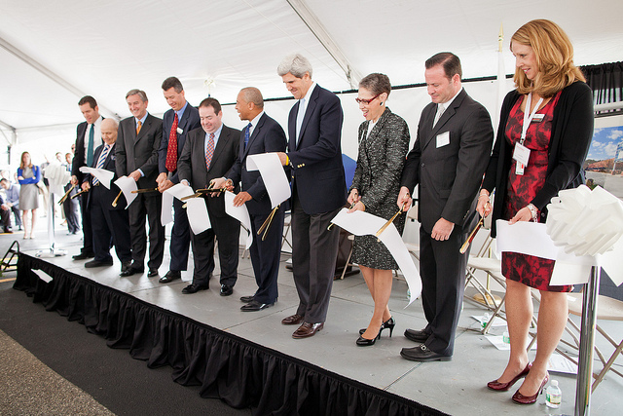
Governor Patrick and U.S. Senator Kerry participate in a ribbon cutting ceremony at Thermo Fisher Scientific's Center for Excellence. (Photo credit: Eric Haynes / Governor's Office). View additional photos.

TEWKSBURY – Monday, June 11, 2012 – Governor Deval Patrick today celebrated the grand opening of Thermo Fisher Scientific’s Center for Excellence for portable analytical instruments. Thermo Fisher’s Tewksbury location currently employs 400, and the additional center will add another 100 jobs in research, development and manufacturing over the next five years. The grand opening served as another event in a series of Massachusetts life sciences growth announcements taking place in the days prior to the BIO International Convention, which opens June 18 at the Boston Convention & Exhibition Center. Last week, Governor Patrick celebrated the grand opening of Navidea Pharmaceuticals’ new business and commercialization facility in Andover.
“Massachusetts leads the world in life sciences thanks to our growth strategy of investing in education, innovation and infrastructure,” said Governor Patrick. “I want to congratulate Thermo Fisher on the opening of their new facility in Tewksbury, and on their plans for future expansion in Massachusetts. We look forward to working with them to create more jobs and opportunities in the Commonwealth.”
The 156,000-square-foot Tewksbury facility is the new home to the company’s comprehensive line of Thermo Scientific portable and analytical instruments.
“Our Commonwealth, with its significant access to talent, investment and innovation, supports growth of life sciences, biotech and high-tech businesses unlike any other state or region,” said Marc N. Casper, president and chief executive officer of Thermo Fisher Scientific. “This new Center of Excellence creates a strong base for our continued growth in portable and handheld instruments – high-tech tools that are enabling our customers to make the world safer. We’ve been able to take analytical technologies that were typically only found in the laboratory, and adapt them for use in the field by non-scientists. Our $20 million investment in this world-class facility reaffirms our commitment to Massachusetts and a growing economy that is fueled by new scientific discoveries.”
There are now more than 1,400 Thermo Fisher employees in Massachusetts. In addition to its global corporate headquarters in Waltham, businesses in the Commonwealth include Environmental and Process Monitoring in Franklin; Water Analysis Instruments in Beverly; and the BRIMS Center in Cambridge, which provides applications assistance in biomarker discovery and validation.
The BIO International Convention will provide Governor Patrick, Lieutenant Governor Timothy Murray, state and industry leaders with an opportunity to showcase Massachusetts as a global leader in the life sciences industry, and the preeminent place for life sciences companies to invest in and expand.
In 2008, Governor Patrick signed a 10-year, $1 billion investment package to strengthen the state’s global leadership in the life sciences. The initiative melds all of the state’s key resources in order to spur research, investment, innovation and commercialization. Now, the life sciences industry in Massachusetts is thriving, with more than 52 percent job growth in the biopharma sector since 2001 and more than 80,000 employees working in the life sciences.

