Governor Patrick Lights First Section of New MassBroadband 123 Fiber-Optic Network

Over 1,200 Community Facilities to Receive Broadband Access
OTIS – Thursday, April 4, 2013 - Governor Deval Patrick today lit the first section of a new 1,200-mile fiber-optic network that will bring high-speed Internet access to underserved areas of western and central Massachusetts. The event was held at the regional Farmington River Elementary School, one of the facilities to be connected to theMassBroadband 123 network.
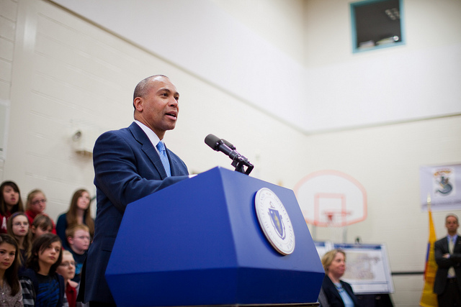
Governor Patrick highlights progress being made on broadband accessibility across the Commonwealth at the Farmington River Regional School in Otis.
(Photo: Eric Haynes / Governor's Office)
View More Photos
“Broadband is essential for Massachusetts to remain competitive,” said Governor Patrick. “Today is a remarkable milestone because now every corner of the Commonwealth will be connected to the educational and economic opportunities everywhere else in the world.”
The MassBroadband 123 network will provide fiber-optic connectivity directly to 1,200 key facilities in more than 120 western and central Massachusetts communities. These Community Anchor Institutions include schools, libraries, municipal buildings and public safety and health care facilities. The section lit up on Thursday runs from Springfield to Sandisfield and includes 51 community institutions. The remaining segments of theMassBroadband 123 network will be powered up in the months ahead.
The Patrick-Murray Administration has been a longtime champion for broadband expansion in unserved and underserved communities to enable residents and businesses to better compete in the 21st century global economy. MassBroadband 123 is a critical component of Governor Patrick's strategy to invest in education, innovation and infrastructure in order to create growth and economic opportunity in every corner of the Commonwealth.
“By connecting businesses and residents in every part of the state to dependable Internet access, we are investing in the type of infrastructure that will help create economic opportunity for everyone,” said Secretary of Housing and Economic Development Greg Bialecki. “High-speed Internet is another asset to Central and Western Massachusetts, along with a well-educated workforce, great quality of life, and easy access to Boston and New York City, that makes these parts of the Commonwealth attractive to a wide range of industries.”
“Nothing is more important to our future than making sure our students have the education and skills they need to compete and succeed in a digital world,” said CEO of the Massachusetts Technology Collaborative Pamela Goldberg. “Today, we take the first step in the crucial process of connecting them to that digital world.”
The immediate benefits of providing fiber-optic connectivity to the 1,200 Community Anchor Institutions include:
- Opportunities to enhance school curriculums. These opportunities include virtual field trips, access to online content such as videos or podcasts, and the opportunities to learn and use digital technologies such as websites, wikis and blogs.
- Greater bandwidth in libraries so that they can meet the increasingly digital needs of local residents. For example, libraries will be able to aid in job searching and training by providing access to job websites and assisting with resume writing and computer skills training. They can assist businesses by being a video conferencing hub and can teach digital literacy to the elderly and disabled.
- Improved and enhanced communications by police and fire departments internally, across departments and with the public. With this new network, police stations across the region will have reliable, fast access to the state Criminal Information database, and be prepared for the next generation 911, which will allow reports to come in via voice, text, email and even videos of an emergency situation.
As part of the network’s launch, a Microsoft Skype demonstration connected students at the Farmington River School with students at a Vive Digital center in Bogota, Colombia and the NASA Goddard Space Flight Center. The Colombian students participated through Vive Digital, Colombia’s comprehensive broadband initiative, with Governor Patrick and members of his Administration met with during his February 2013 trade mission to Colombia.
Governor Patrick and the Legislature created the Massachusetts Broadband Institute at the Massachusetts Technology Collaborative in the Broadband Act of 2008, providing $40 million in state bond funds to start the process of connecting the unconnected in Western Massachusetts. In 2010, $45.4 million in federal stimulus funding was awarded to the Massachusetts Broadband Institute at MassTech through the highly-competitive second round of the National Telecommunications and Information Administration's (NTIA) Broadband Technology Opportunities Program (BTOP).
The MassBroadband 123 network has been developed through industry collaborations, including network operator Axia NGNetworks USA, network builder G4S, owner’s project manager Tilson Technologies and internet service provider Crocker Communications who provided Internet connectivity for the event.
“This exciting milestone would not have happened without the support of the Patrick-Murray Administration, the region’s legislative and congressional delegations, the leadership and staff at MassTech and MBI, and terrific industry project partners and community representatives,” said MBI Director Judy Dumont.
"I have fought hard to bring broadband technology to western and central Massachusetts for many years. There is simply no reason why every resident, business and school in the region should not have reliable high speed internet access in 2013. More than one million people will benefit from this important broadband expansion project when it is completed. If we are going to remain competitive in a 21st Century information based economy, high speed internet access will be critical, said Congressman Richard E. Neal.
"Today is the beginning of the end of the digital divide," said State Senator Benjamin Downing. "Five years ago the MBI embraced its mission to bring high speed Internet to the unserved and underserved communities of western Massachusetts and today is delivering real results. Judy and her team should be congratulated, and I look forward to continuing our partnership as we now turn our attention to building the Last Mile network -- and finally connecting every address in the Commonwealth to the Internet -- together."
As the MassBroadband 123 fiber-optic network begins to connect community anchor institutions, the Massachusetts Broadband Institute is looking forward to developing public-private solutions that bring broadband directly to more homes and businesses in Western Massachusetts. Governor Patrick recently filed bond legislation that contains $40 million in new funding for the Massachusetts Broadband Institute at MassTech. The funding is designed to leverage additional investment toward developing last-mile solutions that bring broadband connectivity directly to homes and businesses in 45 underserved western and central Massachusetts communities.
About the Massachusetts Broadband Institute
The Massachusetts Broadband Institute at MassTech is working to extend affordable high-speed Internet access to all homes, businesses, schools, libraries, medical facilities, government offices, and other public places across the Commonwealth, allowing all regions to participate more fully in the innovation economy. MBI also works to promote broadband usage and adoption by our residents and small businesses. Learn more athttp://broadband.masstech.org.
About the Massachusetts Technology Collaborative
The Massachusetts Technology Collaborative is a public agency working to keep Massachusetts at the forefront of innovation, for the purpose of generating more high-paying jobs, higher productivity, greater economic growth, and improved social welfare. We enhance economic growth, accelerate technology use and adoption, and harness the value of research by engaging in meaningful collaborations across academia, industry, and government. From improving our health care systems and expanding high-speed internet across the state to fostering new and emerging sectors, MassTech is driving innovation and supporting a vibrant economy across the Commonwealth. Learn more atwww.masstech.org.

