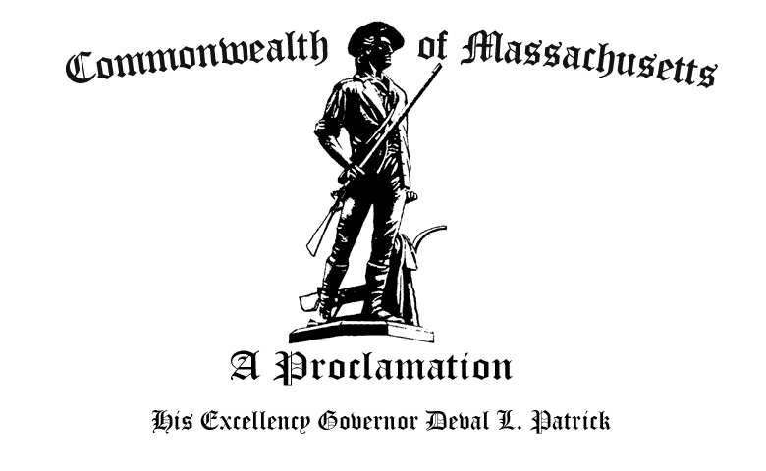

W
hereas Garifuna Americans continue to be a vital part of the Commonwealth’s rich diversity by contributing significantly to all aspects of daily life, including education, medicine, agriculture, public service and technology; and

W
hereas Garifuna Americans can trace their heritage to a diverse group of nations such as Belize, Honduras, Nicaragua and Guatemala; and

W
hereas Garifuna Americans celebrate the 209th anniversary of their settlement in Belize and Nicaragua; and

W
hereas Garifuna Americans have a rich interaction with the Commonwealth as evidenced by the settlement of the Garifuna people to Boston; and

W
hereas It is appropriate that all residents recognize Garifuna immigrants and their rich cultural traditions and writings,

N
ow, Therefore, I, Deval L. Patrick, Governor of the Commonwealth of Massachusetts, do hereby proclaim November 12, 2011 through December 12, 2011 to be

Garifuna Settlement Education and Awareness Month

And urge all the citizens of the Commonwealth to take cognizance of this event and participate fittingly in its observance.

Given at the Executive Chamber in Boston, this fourth day of November, in the year two thousand and eleven, and of the Independence of the United States of America, the two hundred and thirty-fifth.

By His Excellency

Deval L. Patrick
Governor of the Commonwealth

William Francis Galvin
Secretary of the Commonwealth

God Save the Commonwealth of Massachusetts

